

2014

Prepared by:

North Shore Water Utility
Nelson Ltd.
(
NSWU
)

2025

Annual Report

© AquaDiversities Inc.
, 20
2
6

ALL RIGHTS RESERVED. This report

is copyrighted and contains proprietary and
privileged technical information that is the intellectual property of AquaDiversities Inc.
Any unauthorized reprint or use of this material is prohibited

May

202
6

Version 2.0

Table of Contents
1.0 Introduction 3
2.0 Water System Overview 3
2.1 Source Description 3
2.2 Regulatory Requirements 3
2.3 Treatment System Description 4
2.4 Delivery and Distribution 4
3.0 Consumption Data 4
4.0 Operational Improvements and Capital Upgrades 4
4.1 Improvements to Date 4
4.2 Future Operational Improvements 5
5.0 Water Quality Monitoring Program 5
5.1 Parameters for Water Quality Monitoring 5
5.2 Real-time Monitoring 6
5.3 Microbiological Monitoring 6
5.4 Chemical Monitoring 7
5.5 Volume Monitoring at Reservoirs 7
6.0 Water Quality Concerns 7
7.0 Major Operational Events 8
8.0 Future Water Treatment 8
9.0 EOCP Classification and Certification 8
10.0 Summary 8
2025 Monthly Reports Page 10-111
List of Tables
Table No. 1 - Water Quality Standards for Potable Water ............................................................................ 5
Table No. 2 - Real-time Monitoring Results................................................................................................... 6
Table No. 3 - Microbiological Monitoring Results ......................................................................................... 6

1.0 Introduction
As part of the conditions outlined in the Interior Health Authority Operating Permit for the North Shore Water Utility Nelson Ltd. (NSWU), this document will summarize and report the operations and maintenance of the utility in 2025 under the management of AquaDiversities Waterworks Inc. (Aqua).
Future treatment upgrades plans and customer feedback has also been included in this report. In an effort to provide transparency and inform the customers of the utility, this report will be posted on the NSWU website at http://northshorewaterutility.com.
Since September 2014 Aqua has owned and operated NSWU (a private water utility) under the Water Utility Act. The act regulates utilities to ensure the provision of safe and adequate water service at rates that are fair, reasonable and sufficient to operate their water systems sustainably.

2.0 Water System Overview
NSWU has been in operation since 1978 and services 152 residential connections and 10 commercial connections that includes two motels, commercial buildings and a school.

2.1 Source Description
The surface water that supplies NSWU comes from two parallel sources consisting of high flow springs exiting the steep mountainside. They are known as Sutherland Creek and Collin Spring/Isaac Creek. Each of the sources has a wooden frame structure built over the spring to protect the intake infiltration galleries. These intakes supply the two 25,000 imperial gallon reservoirs (one located at each source). Flow to the reservoirs is controlled by an on-demand system of level switches and actuating valves. Access to each reservoir is contained within a building that houses the treatment components of the system and is locked to prevent unauthorized access. Both reservoirs are at the same elevation, providing gravity flow to the distribution system. In the high consumption summer months, both reservoirs are utilized to meet the demand of the consumers. For the majority of the year, the Collin Spring/Isaac Creek reservoir provides sufficient supply to meet the demand.

2.2 Regulatory Requirements
Interior Health Authority (IHA) is the regulatory agency for the NSWU. In British Columbia, water quality standards for potable water are regulated by Drinking Water Protection Act (2001), which provides the basic, minimum framework towards goals for drinking water treatment for pathogens in surface water supply systems. Specific water quality standards, monitoring schedules, applicability and recommended treatments are outlined in the Drinking Water Protection Regulation (2003). The objectives outlined in the Guidelines for Canadian Drinking Water Quality (Health Canada 2012) as well as the Drinking Water Treatment Objectives for Surface Water Supplies in British Columbia (2012) are used to provide the treatment parameters for the treatment objectives implemented by the IHA. All results are reported to IHA to ensure compliance.

2.3 Treatment System Description
The system utilizes NSF approved chlorination disinfection to maintain the recommended operational range within the distribution system as outlined in the Guidelines for Canadian Drinking Water Quality. Each reservoir building houses a chemical dosing pump that doses 12% sodium hypochlorite (chlorine) proportionally to the flow of water being delivered to the reservoir. Aqua maintains the minimum level of chlorine required to ensure safe drinking water while preserving aesthetic quality.

2.4 Delivery and Distribution
The system provides potable water to approximately 2.5 km of distribution system main via gravity flow. The distribution system is comprised primarily of 6” diameter PVC, with some 2” and 4” diameter pipe. There are 11 fire hydrants and seven standpipes that are utilized for system flushing. Each house has a curb stop valve connected to the main, which allows for isolation of the residence. In 2019 an extension of the NSWU was completed with an additional five new connections along a 6” main which included three new hydrants. In June 2024, the service connection under highway 3A was upgraded to 6" C900 PVC in line with municipal standard.

3.0 Consumption Data
As part of a pilot project, a totalizing non-intrusive (bolted to outside of pipe) flow meter was installed at Isaac Creek. Average daily consumption and average flow (m³/hour) was reported monthly since installation.
The following flow information was extrapolated for 2025:
- Average daily consumption from January 1st – December 31st = 195.27 m³/day
- Average daily flow = 8.14 m³/hour
- Total flow in 2024 = 71,274 m³

This is a decrease over 2024 consumption of: 15.55 m³/day, 0.56 m³/hour and overall total flow decrease of 5,674 m³.

4.0 Operational Improvements and Capital Upgrades

4.1 Improvements to Date
Since 2014 and throughout 2025, Aqua has worked diligently to ensure safe drinking water to the consumers of NSWU while making improvements to the aging infrastructure and acquiring/documenting increased knowledge on the system.

Upgrades and improvements made to the NSWU in 2025 include:
- Patched leak in Sutherland reservoir.
- Fell standing dead trees around Sutherland reservoir and intake.
- Installed 1 Brooks Box below Sutherland reservoir.
- Installed 1 Brooks Box at standpipe 14.
Operational tasks completed on the NSWU in 2025 include but are not limited to:
- Sutherland intake building structure repairs.
- Maintaining/implementing a Water Conservation Program with established procedures for administering water restrictions, as well as water conservation tips for users.
- Routinely clean and inspect storage reservoirs.
- Hydrant maintenance, exercising and greasing.
- Distribution system flushing.
- Exercising of all main control isolation valves.

4.2 Future Operational Improvements
- More clearing of standing dead and mitigation of danger trees around Isaac and Sutherland reservoirs and intakes.
- Add an air admittance valve to the distribution system to prevent negative pressure.
- Hydrant repair at Lower Valhalla Rd.
- Install a ladder at the Isaac reservoir for worker safety.
- Acquire hydrant diffusers to mitigate erosion while flushing the system.

5.0 Water Quality Monitoring Program
A Water Quality Monitoring Program provides established schedules for systematic, routine sampling to ensure that the parameters outlined in the Guidelines for Canadian Drinking Water Quality are maintained. The NSWU monitoring program has been developed with the approval of the EHO.

5.1 Parameters for Water Quality Monitoring
Parameters for water quality monitoring applicable to treatment currently being implemented at NSWU are summarized in Table No. 1 below, with the exception of chemical parameters which can be found in the following link: http://www.hc-sc.gc.ca/ewh-semt/pubs/water-eau/sum_guideres_recom/index-eng.php#t2.

Table No. 1 - Water Quality Standards for Potable Water
Parameter | Standard
Fecal Coliform Bacteria | No detectable fecal coliform bacteria per 100 ml
Escherichia Coli (E. Coli) | No detectable E. Coli per 100 ml
Total Coliform Bacteria | At least 90% of samples have no detectable total coliform bacteria per 100 ml and no sample has more than 10 total coliform bacteria per 100 ml.
Turbidity | Less than or equal to 1 Nephelometric Turbidity Unit (NTU)
Chlorine Residual | Greater than or equal to 0.2 mg/L at the end of the distribution system.

5.2 Real-time Monitoring
Real-time monitoring is data collected by the operators on an interval determined by the local EHO for turbidity and chlorine residual to ensure they are within drinking water quality standards. In house data is collected (NTU and Cl2) are collected three times per week at one or both reservoirs, depending on operation, and at two locations at the ends of the distribution system twice per week. The system is also monitored remotely on a daily basis. Results are forwarded to the EHO in the Operator Log Sheets as part of the Monthly Report. Any sample results that fall outside of the standards are immediately addressed in accordance to the procedures outlined in the ERP.

Table No. 2 - Real-time Monitoring Results
Parameter | No. of  Samples  Taken (2025) | Range | Samples Outside of Standards
Turbidity (Reservoir) | 160 | 0.09 – 4.14 NTU | N/A
Chlorine Residual Distribution- 570 Johnstone Rd. | 100 | 0.29 – 1.5mg/L | 0
Chlorine Residual Distribution –Main Jet | 100 | 0.35 – 1.35mg/L | 0
Chlorine Residual Reservoir | 167 | 0.31 – 1.70mg/L | 0

5.3 Microbiological Monitoring
Microbiological monitoring occurs through bi-weekly sample collections at two locations in the distribution system. These samples are sent to a provincially accredited lab and tested for total and fecal coliforms. Table No. 2 outlines the number of samples and results from this monitoring. Samples collected that exceed the parameters are immediately reported to the EHO and responded to in accordance to the procedures outlined in the ERP.

Table No. 3 - Microbiological Monitoring Results
Parameter | Number of Samples | Number of Exceedances
E. Coli | 26 | 0
Total Coliform | 26 | 0

5.4 Chemical Monitoring
A comprehensive chemical analysis is recommended every three years to ensure there are no exceedances to the Maximum Allowable Concentration (MAC) as defined in Guidelines for Canadian Drinking Water Quality. A routine comprehensive chemical analysis was performed at both intakes was conducted in August 2024. Full chemical analysis results can be found on the NSWU website at http://northshorewaterutility.com.

5.5 Volume Monitoring at Reservoirs
Operators monitor the volumes at the Isaac Creek reservoir closely in order to determine when the reservoir at Sutherland Creek will need to be brought online to supply the increased demand. On June, 10th 2025 the Sutherland reservoir was brough online in anticipation of an increase in summer water demand on the NSWU. It remained on-line until September 30th, 2025. Level 1 Water
Conservation Measures (watering restrictions) were in effect from June 10th to October 10th in 2025.

6.0 Water Quality Concerns
Although the water source at NSWU is of pristine quality, seasonal turbidity issues remain a concern, particularly with high precipitation weather events and spring freshet. The Drinking Water Treatment Objectives for Surface Water Supplies in BC (November 2012) states the following:
“For non-filtered surface water to be acceptable as a drinking water source supply…turbidity levels of around 1 NTU but not exceeding 5.0 NTU for more than 2 days in a 12-month period should be demonstrated in the absence of filtration.”
The NSWU had a Water Quality Advisory (WQA) in place from March 27th to April 24th, and December
11th that extended into 2026. The average turbidity throughout the duration of the WQA was 0.87
NTU between March 27th and April 24th and 1.34 NTU during the month of December of 2025. The WQA can be attributed to an influx of natural organic matter due to heavy amounts of melting snow and heavy rainfall events, it should be noted that chlorine residuals were monitored and maintained daily throughout the WQA period.
In an effort to mitigate turbidity levels above 1 NTU, operators clean both intakes on regular intervals to remove sediment build-up. Each reservoir is also cleaned out once per calendar year.

7.0 Major Operational Events
- On January 15th there was a temporary water shutoff for Parkview Rd customers to repair a water main leak. Water was restored on January 16th.
- On June 9th NSWU crews were on site at 541 Johnstone Rd to conduct water line repairs.
- On June 23rd NSWU crews performed a distribution system flush.
- Oct 7th NSWU crews repaired leaking water main on upper Parkview Rd. Water was shut off to the street for a couple hours, affected customers were notified.
- Oct 10th NSWU crews performed emergency replacement of curb stop on Parkview Rd had to shut off water to multiple houses, customers were notified.
Communication methods for emergency repairs as well as routine maintenance included electronic alerts, customer email notification and sandwich boards in residential areas. These notifications will continue to be employed to ensure effective communication to all customers of the NSWU.

8.0 Future Water Treatment
In August 2016 a pilot treatment system project was installed at the Isaac Creek reservoir. This pilot system includes sand filtration, cartridge filtration, ultra-violet treatment, and a totalizing flow meter to the existing chlorination treatment. The pilot remains installed but at the time of report writing is not collecting data. Past accrued knowledge will aid in developing a long-term plan for installing the water system to achieve treatment levels that meet the Drinking Water Treatment Objectives for Surface Water Supplies in British Columbia.

9.0 EOCP Classification and Certification
The Environmental Operators Certification Program (EOCP) classifications are done in accordance with the B.C. Guidelines that were established based on the classification templates developed in conjunction with the Association of Boards of Certification. It is used to determine the level of Operator Certification required to operate and maintain the treatment system and is reclassified every 5 years. NSWU was renewed as a Small Water System by the EOCP in September 2021 and as such requires a certified operator.

10.0 Summary
Throughout the 2025 operating season NSWU water quality results were within the Maximum Acceptable Concentrations (MAC) identified in the Guidelines for Canadian Drinking Water Quality. Operation and maintenance issues were resolved in a timely manner by AquaDiversities.
Overall, in 2025 the NSWU system was very stable, showing overall excellent water quality. The only concern being the elevated turbidity during periods of high precipitation and spring freshet. Future upgrades to the NSWU are planned for 2026-2029, including potential plans to build a water treatment system. Future upgrades will be implemented to comply with regulatory requirements (IHA) in an effort to provide the customers of the NSWU a safe and sustainable potable water source and a satisfying relationship with the utility.

This report is for information purposes only. Aqua Diversities Inc. has provided accurate information to the best of their ability, and is not responsible for the inaccuracies that may occur from the collection of monitoring data.

North Shore Water Utility Nelson Ltd. Monthly Report

To: Jennifer Beverly, Large Water Systems Environmental Health Officer, Interior Health Authority
From: Aqua Diversities Waterworks Inc.
Date: February 7th, 2025
Re: Monthly Report for North Shore Water Utility - January 2025

This document includes the following items as part of the monthly report for the North Shore Water Utility Nelson Ltd. (NSWU):
1.0 Daily Water Consumption
2.0 Microbiological Test Results
3.0 Operator Log Sheets and Water Quality Events
4.0 Major Operational Events
5.0 Records of Customer Feedback and Response
Submission of this report is to enhance communication with the local Environment Health Officer (EHO) and meet requirements for status compliance on the conditions summarized in the Operating Permit.
1.0 Daily Water Consumption
Total water consumption in January was 4,854m³; average daily consumption was 156.5m³/day. The average flow was 6.52m³/hr.

2.0 Microbiological Test Results
A sample from both ends of the distribution system is collected and submitted to an accredited laboratory for bimonthly microbiological testing.
All monthly testing results satisfy the Maximum Allowable Concentration (MAC) standard as set out by the Guidelines for Canadian Drinking Water Quality (GCDWQ). See Appendix A for Laboratory Results

3.0 Operator Log Sheets and Water Quality Events
NSWU continues to be tested on an every-other-day schedule as specified by the EHO. The log sheets include comments on the source, treatment, and distribution system events. Log sheets also include information on the weather for the corresponding test date, which helps correlate weather events to turbidity levels.
Throughout the month of January, chlorine residuals were maintained above 0.2 mg/L across the distribution system.
See Appendix B for Operator Log Sheets.

4.0 Major Operational Events
A break in the main line at the intersection of Parkview and Parkview west. The line was exposed with HVAC and excavator then the line was repaired and buried back to grade. Customers in affected area were notified of brief water shut off to complete repairs.

5.0 Records of Customer Feedback and Response
There were no customer inquiries in the month of January.

Report Reviewed by:

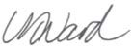
Nicole Ward, BSc.P.Ag. Project Manager

Appendix A
Laboratory Results

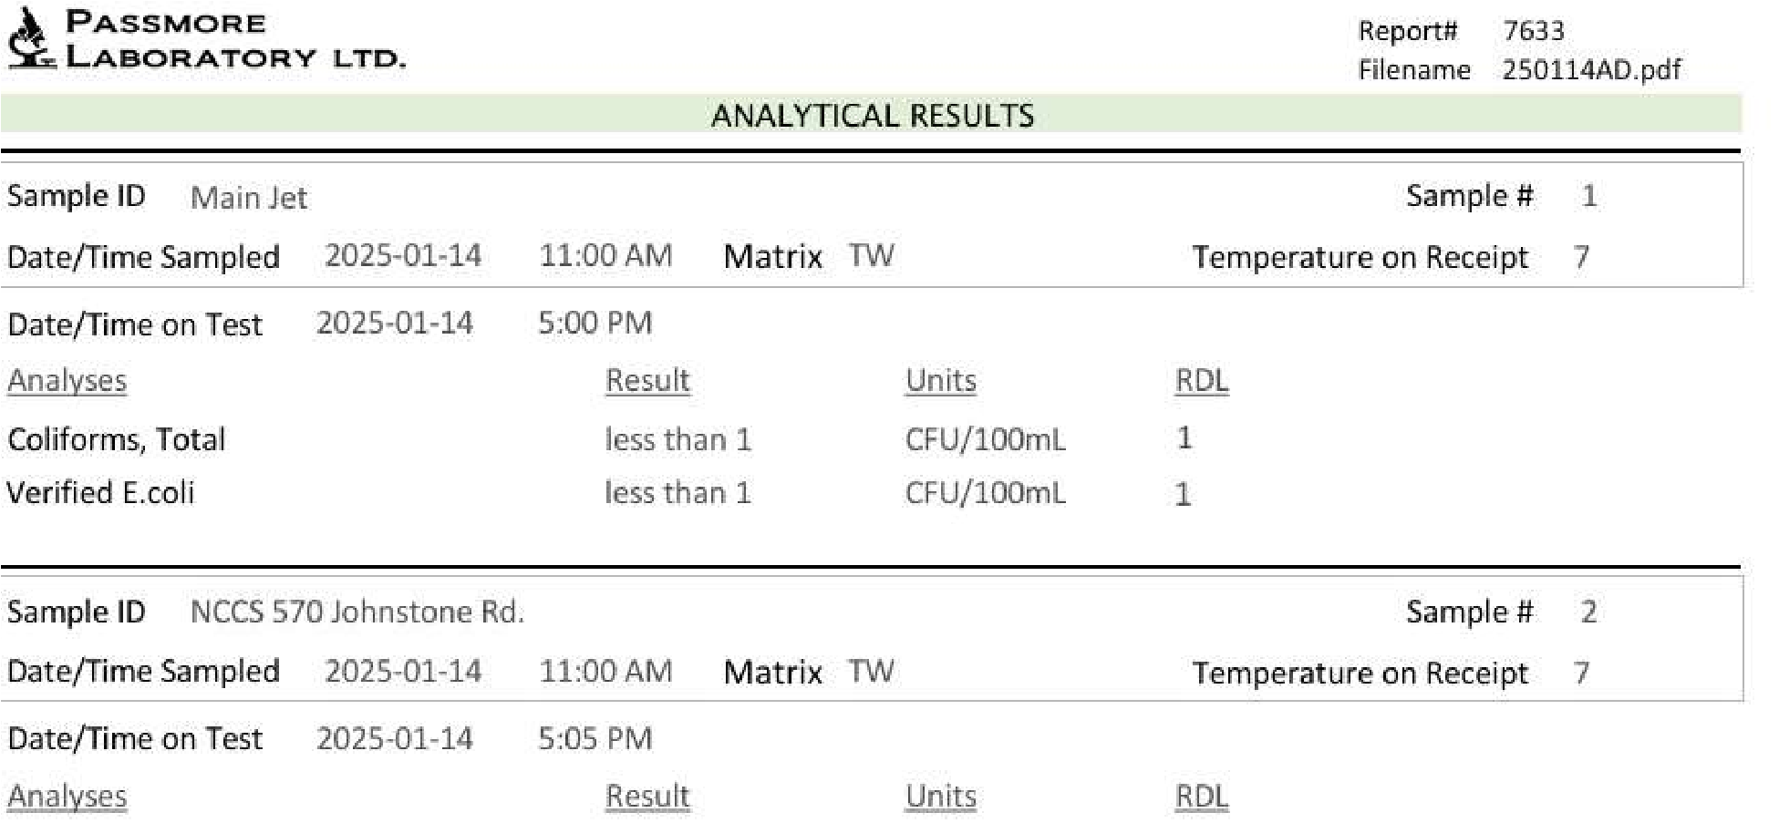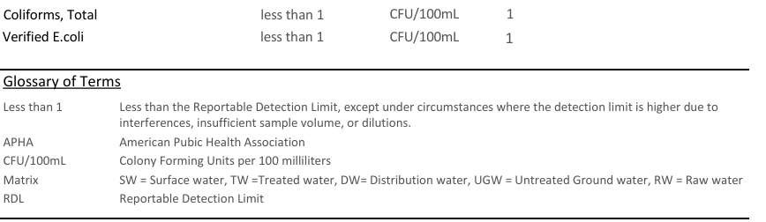

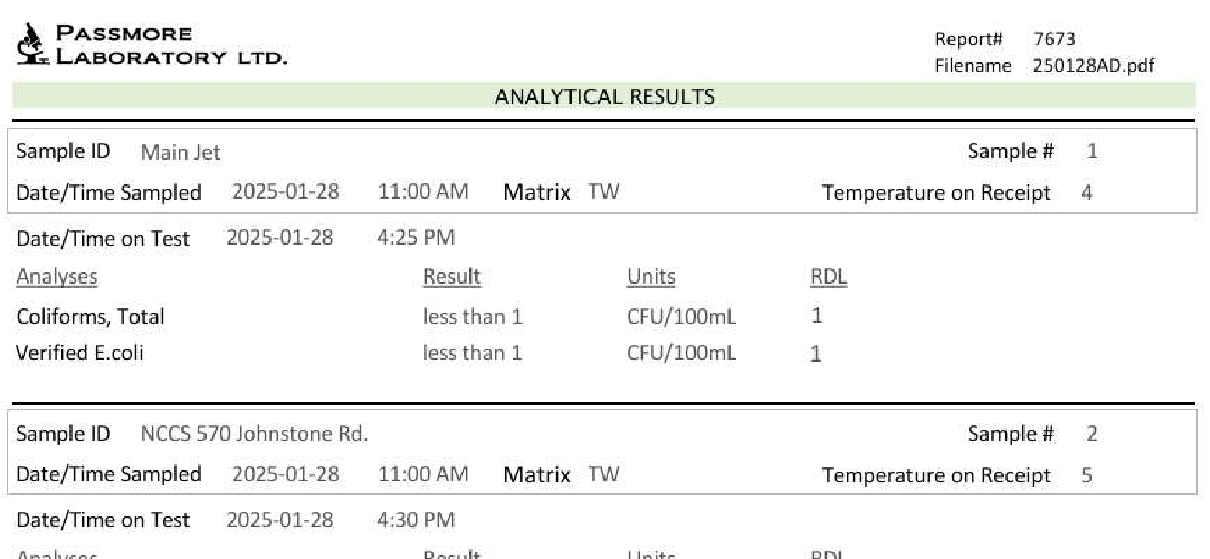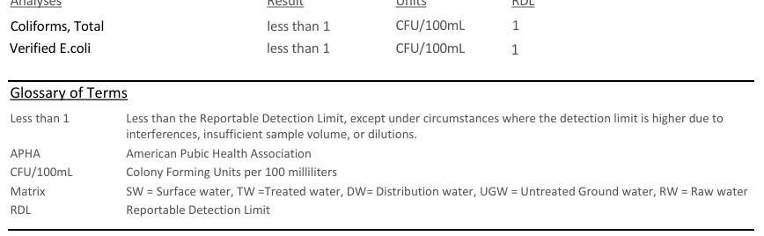

Appendix B
Operator Log Sheet

Appendix C
Field Memos

North Shore Water Utility Nelson Ltd. Monthly Report

To: Jennifer Beverly, Large Water Systems Environmental Health Officer, Interior Health Authority
From: Aqua Diversities Waterworks Inc.
Date: March 31st, 2025
Re: Monthly Report for North Shore Water Utility - February 2025

This document includes the following items as part of the monthly report for the North Shore Water Utility Nelson Ltd. (NSWU):

1.0 Daily Water Consumption

2.0 Microbiological Test Results

3.0 Operator Log Sheets and Water Quality Events

4.0 Major Operational Events

5.0 Records of Customer Feedback and Response
Submission of this report is to enhance communication with the local Environment Health Officer (EHO) and meet requirements for status compliance on the conditions summarized in the Operating Permit.

1.0 Daily Water Consumption
Total water consumption in February was 4,620m³; average daily consumption was 165m³/day. The average flow was 6.87m³/hr.

2.0 Microbiological Test Results
A sample from both ends of the distribution system is collected and submitted to an accredited laboratory for bimonthly microbiological testing.
All monthly testing results satisfy the Maximum Allowable Concentration (MAC) standard as set out by the Guidelines for Canadian Drinking Water Quality (GCDWQ).
See Appendix A for Laboratory Results

3.0 Operator Log Sheets and Water Quality Events
NSWU continues to be tested on an every-other-day schedule as specified by the EHO. The log sheets include comments on the source, treatment, and distribution system events. Log sheets also include information on the weather for the corresponding test date, which helps correlate weather events to turbidity levels.
Throughout the month of February, chlorine residuals were maintained above 0.2 mg/L across the distribution system.
See Appendix B for Operator Log Sheets.

4.0 Major Operational Events
There were no major operational events for the month of February.

5.0 Records of Customer Feedback and Response
There were no customer inquiries in the month of February.

Report Reviewed by:

Nicole Ward, BSc.P.Ag. Project Manager

Appendix A
Laboratory Results

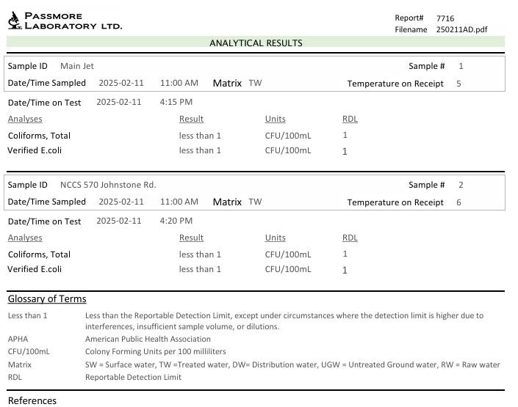

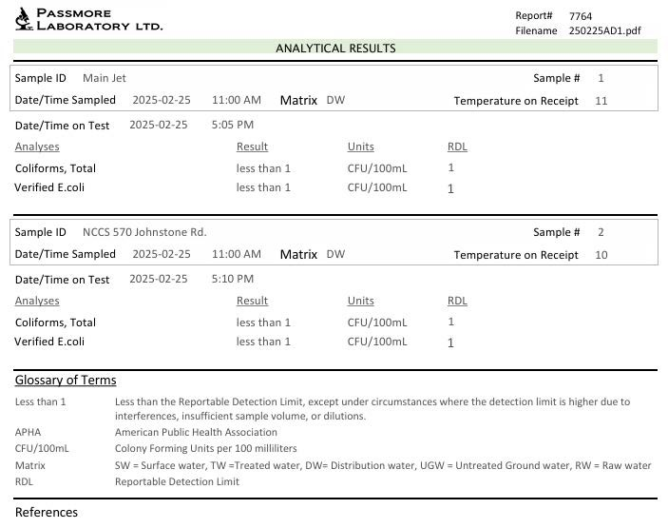

Appendix B
Operator Log Sheet

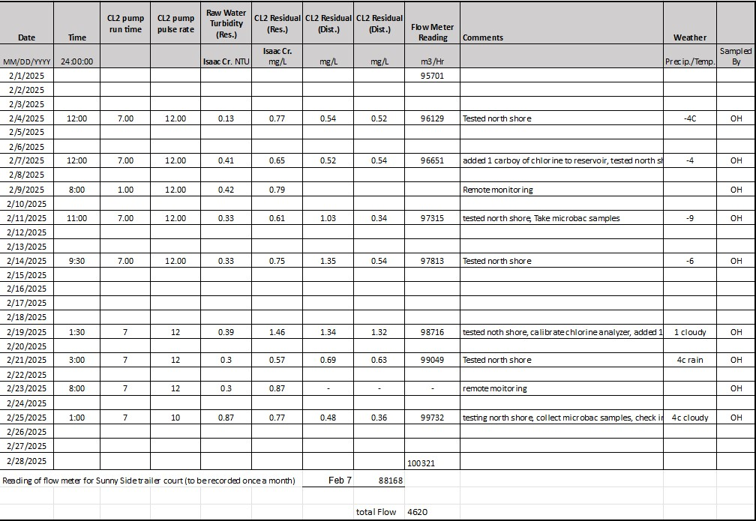

North Shore Water Utility Nelson Ltd. Monthly Report

To: Jennifer Beverly, Large Water Systems Environmental Health Officer, Interior Health Authority
From: Aqua Diversities Waterworks Inc.
Date: April 1st, 2025
R e: Monthly Report for North Shore Water Utility - March 2025

This document includes the following items as part of the monthly report for the North Shore Water Utility Nelson Ltd. (NSWU):

1.0 Daily Water Consumption

2.0 Microbiological Test Results

3.0 Operator Log Sheets and Water Quality Events

4.0 Major Operational Events

5.0 Records of Customer Feedback and Response
Submission of this report is to enhance communication with the local Environment Health Officer (EHO) and meet requirements for status compliance on the conditions summarized in the Operating Permit.

1.0 Daily Water Consumption
Total water consumption in March was 5,156m³; average daily consumption was 166.32m³/day. The average flow was 6.93m³/hr.

2.0 Microbiological Test Results
A sample from both ends of the distribution system is collected and submitted to an accredited laboratory for bimonthly microbiological testing.
All monthly testing results satisfy the Maximum Allowable Concentration (MAC) standard as set out by the Guidelines for Canadian Drinking Water Quality (GCDWQ).
See Appendix A for Laboratory Results

3.0 Operator Log Sheets and Water Quality Events
NSWU continues to be tested on an every-other-day schedule as specified by the EHO. The log sheets include comments on the source, treatment, and distribution system events. Log sheets also include information on the weather for the corresponding test date, which helps correlate weather events to turbidity levels.
Throughout the month of March, chlorine residuals were maintained above 0.2 mg/L across the distribution system.
See Appendix B for Operator Log Sheets.

4.0 Major Operational Events
A pressure switch failed at the Isaac reservoir leading to a faulty chlorine residual reading, the pressure switch was replaced immediately causing the chlorine reading to go back to normal parameters.
Large dead trees and debris removal at Southerland intake & Isaac completed as well as intake cleaning.

5.0 Records of Customer Feedback and Response
There were no customer inquiries in the month of March.

Report Reviewed by:

Nicole Ward, BSc.P.Ag. Project Manager

Appendix A
Laboratory Results

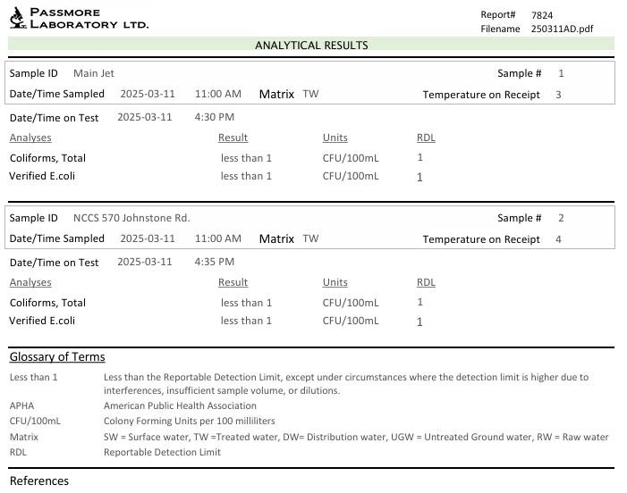

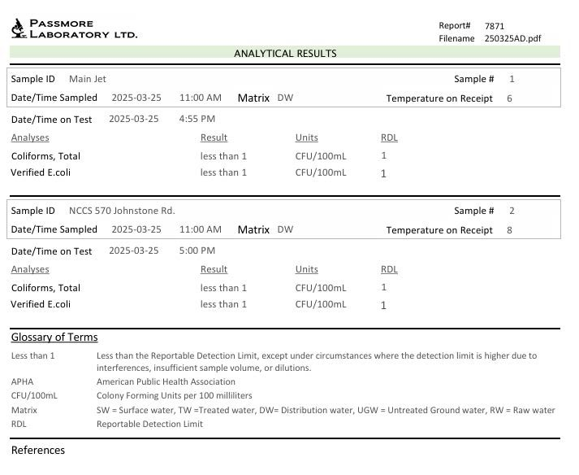

Appendix B
Operator Log Sheet

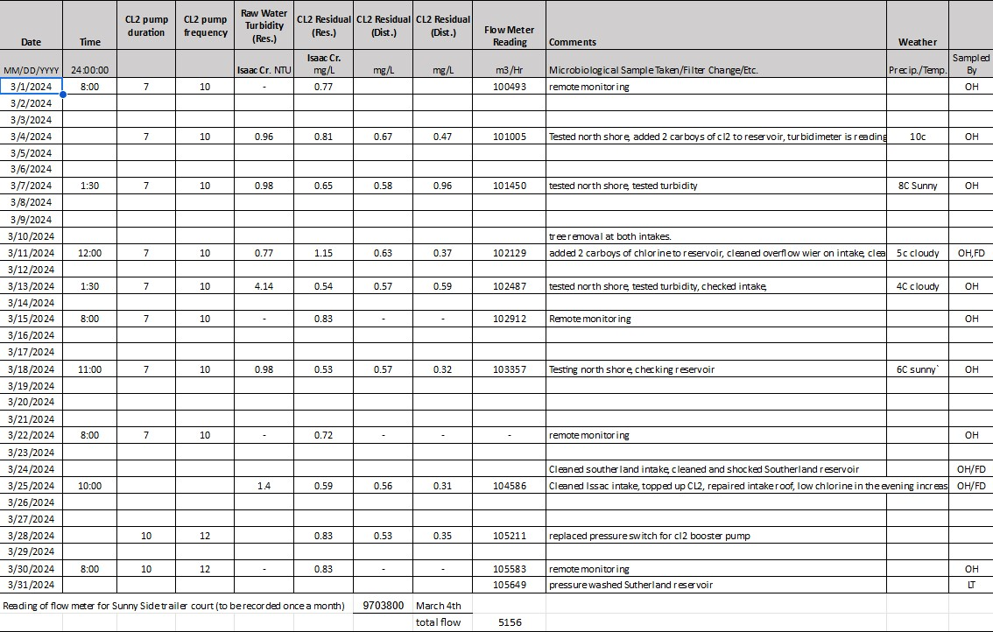

Appendix C
Field Memos

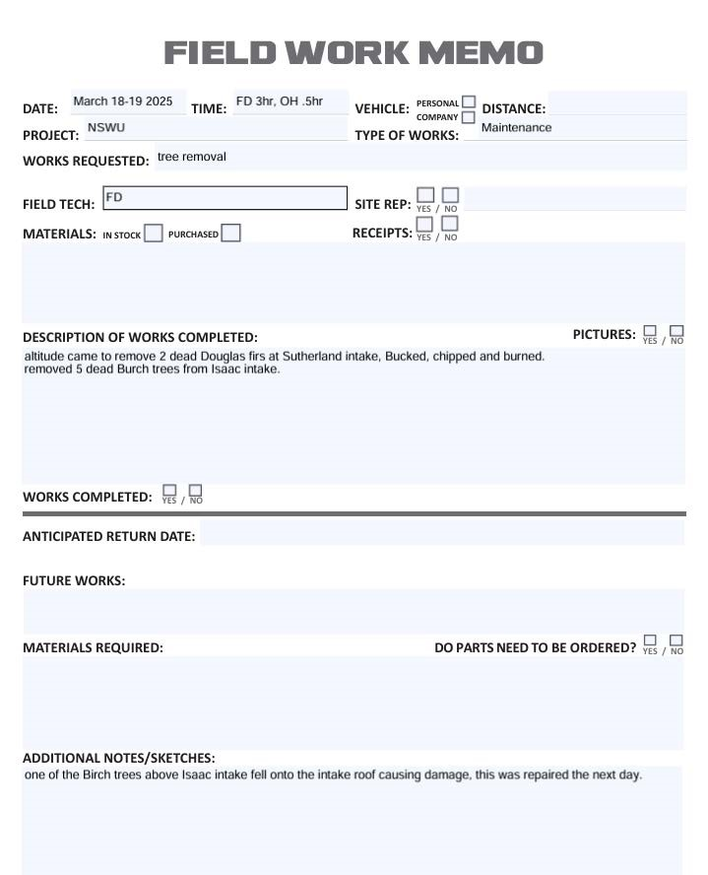
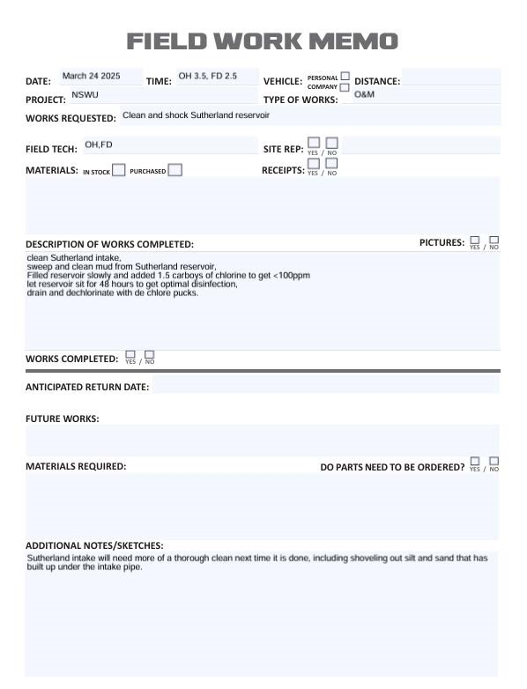
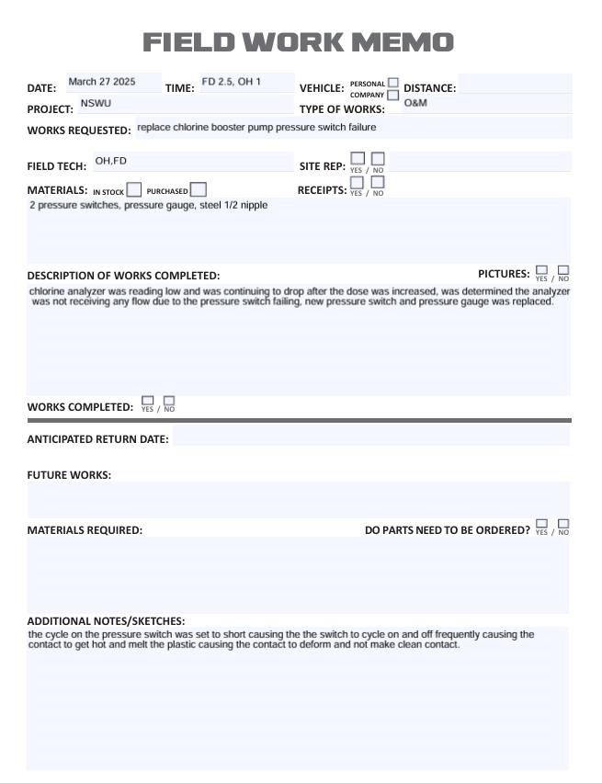

North Shore Water Utility Nelson Ltd. Monthly Report

To: Jennifer Beverly, Large Water Systems Environmental Health Officer, Interior Health Authority
From: Aqua Diversities Waterworks Inc.
Date: May 7th, 2025
Re: Monthly Report for North Shore Water Utility - April 2025

This document includes the following items as part of the monthly report for the North Shore Water Utility Nelson Ltd. (NSWU):
1.0 Daily Water Consumption
2.0 Microbiological Test Results
3.0 Operator Log Sheets and Water Quality Events
4.0 Major Operational Events
5.0 Records of Customer Feedback and Response
Submission of this report is to enhance communication with the local Environment Health Officer (EHO) and meet requirements for status compliance on the conditions summarized in the Operating Permit.
1.0 Daily Water Consumption
Total water consumption in April was 5,573m³; average daily consumption was 185.76m³/day. The average flow was 7.74m³/hr.

2.0 Microbiological Test Results
A sample from both ends of the distribution system is collected and submitted to an accredited laboratory for bimonthly microbiological testing.
All monthly testing results satisfy the Maximum Allowable Concentration (MAC) standard as set out by the Guidelines for Canadian Drinking Water Quality (GCDWQ). See Appendix A for Laboratory Results

3.0 Operator Log Sheets and Water Quality Events
NSWU continues to be tested on an every-other-day schedule as specified by the EHO. The log sheets include comments on the source, treatment, and distribution system events. Log sheets also include information on the weather for the corresponding test date, which helps correlate weather events to turbidity levels.
Throughout the month of April, chlorine residuals were maintained above 0.2 mg/L across the distribution system.
See Appendix B for Operator Log Sheets.

4.0 Major Operational Events
On April 24 the water quality advisory issued March 27,2025 was rescinded.

5.0 Records of Customer Feedback and Response
There were no customer inquiries in the month of April.

Report Reviewed by:

Nicole Ward, BSc.P.Ag. Project Manager

Appendix A
Laboratory Results

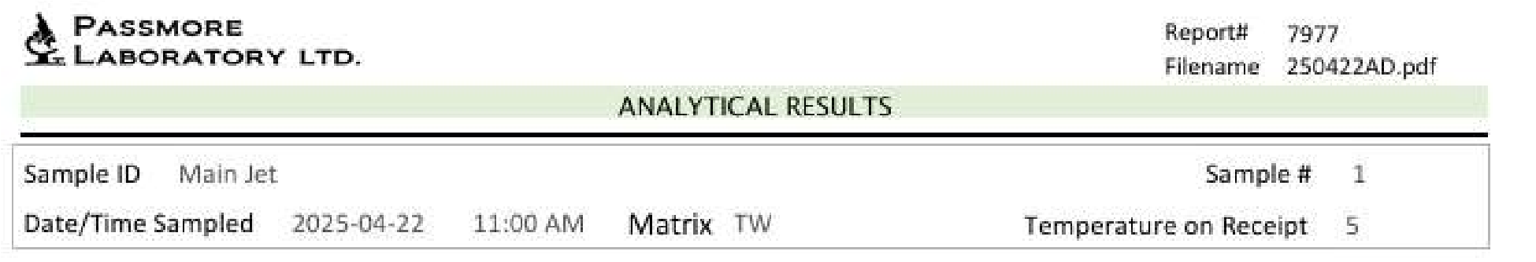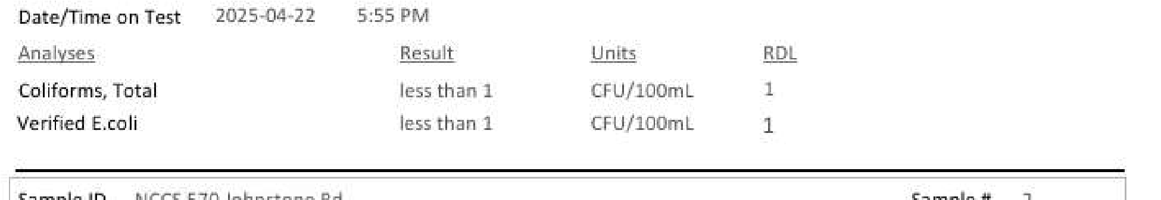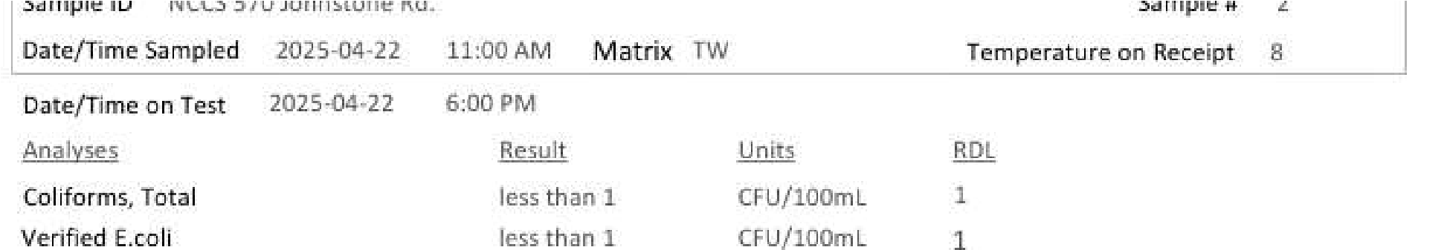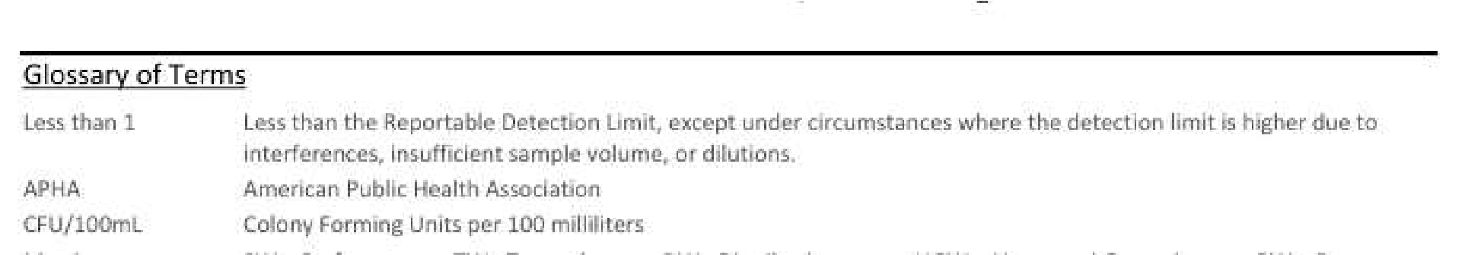
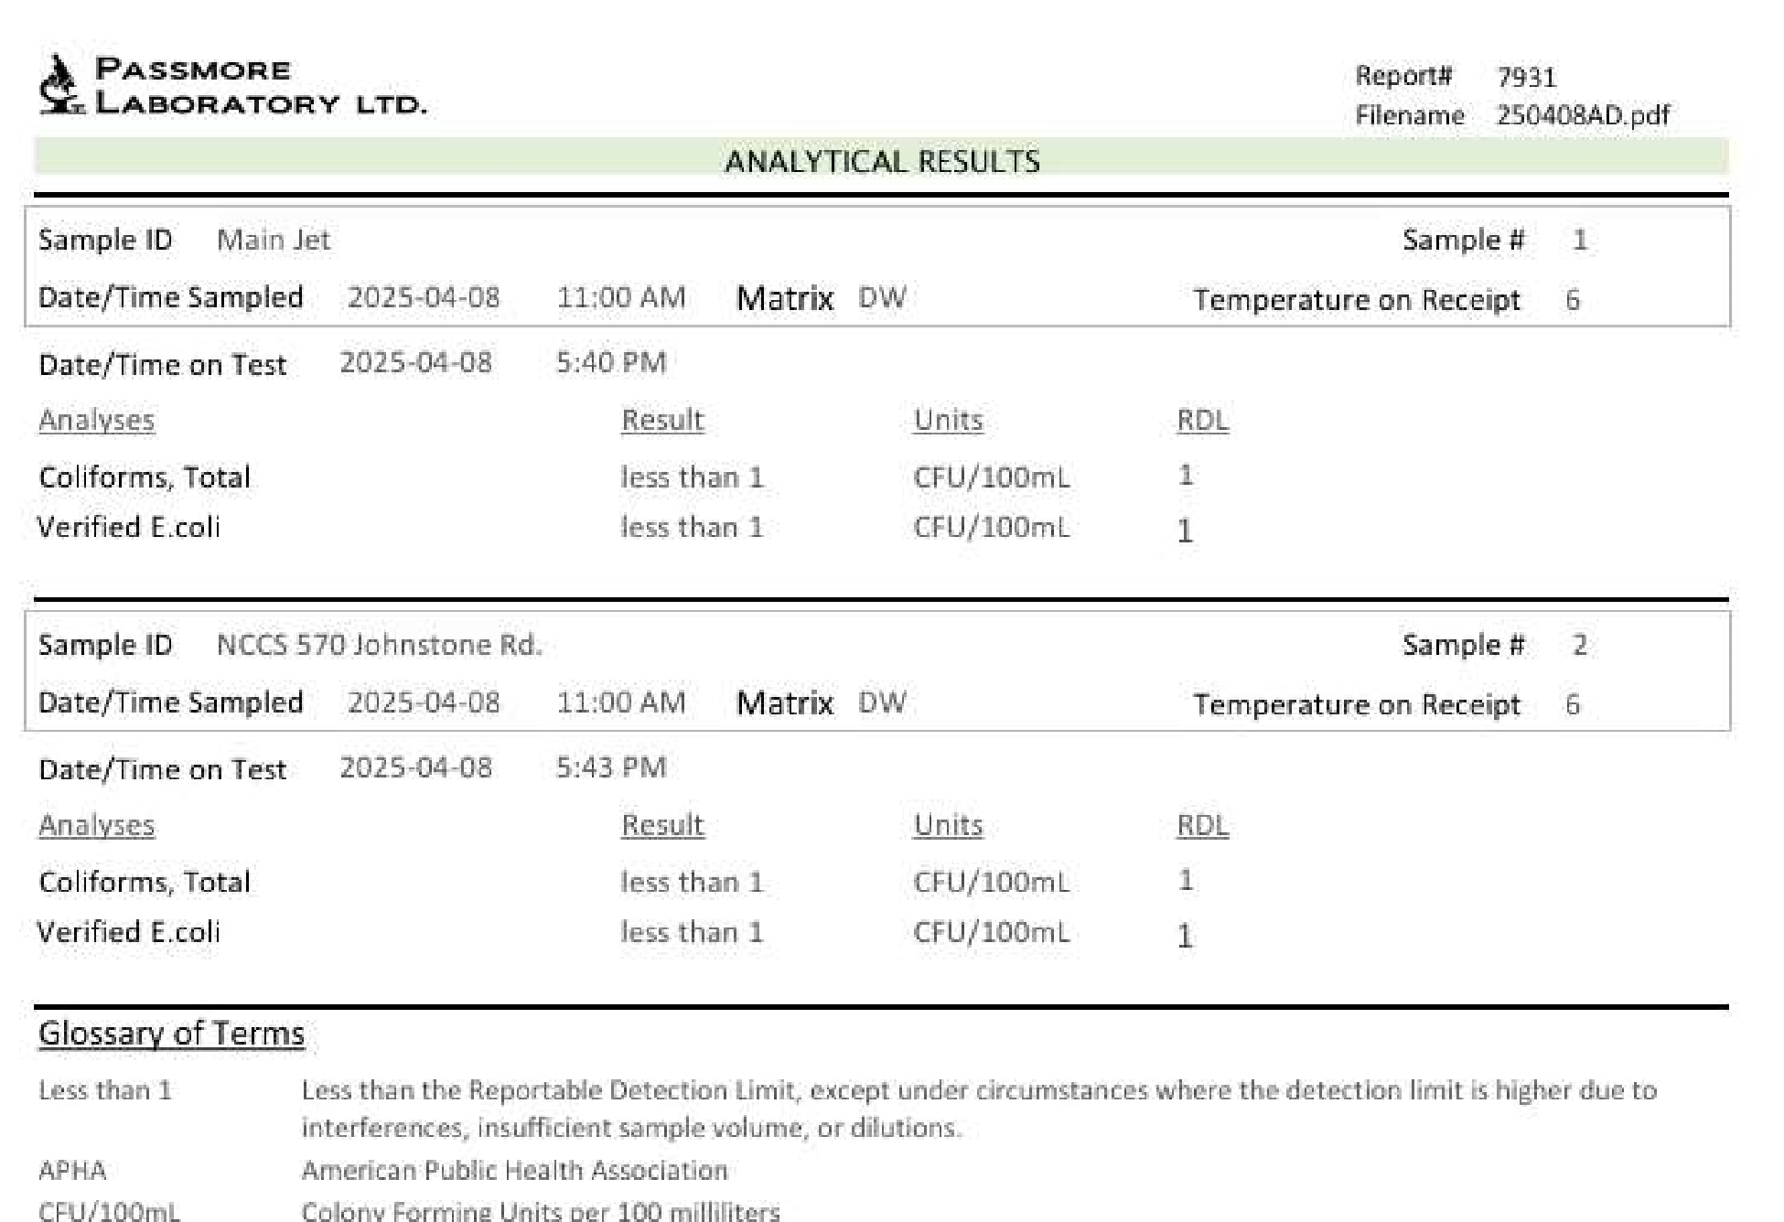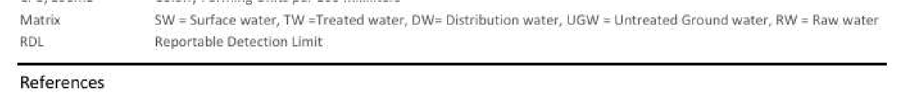

Appendix B
Operator Log Sheet

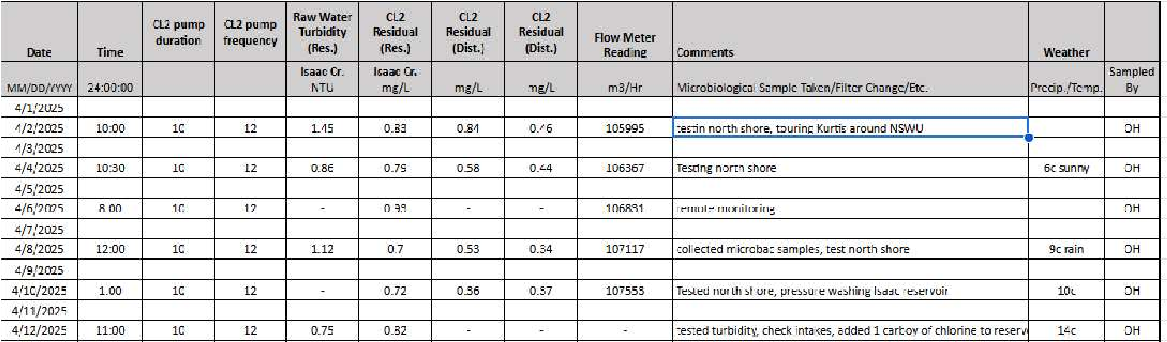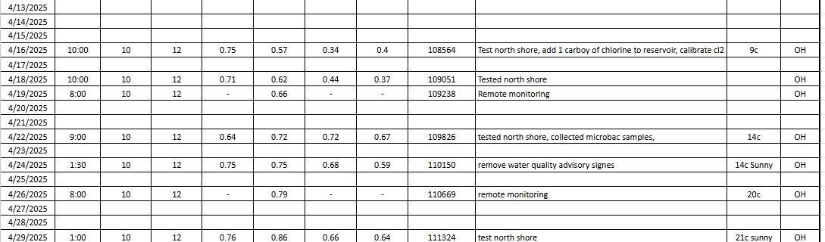

North Shore Water Utility Nelson Ltd. Monthly Report

To: Jennifer Beverly, Large Water Systems Environmental Health Officer, Interior Health Authority
From: Aqua Diversities Waterworks Inc.
Date: June 3rd, 2025
Re: Monthly Report for North Shore Water Utility - May 2025

This document includes the following items as part of the monthly report for the North Shore Water Utility Nelson Ltd. (NSWU):
1.0 Daily Water Consumption
2.0 Microbiological Test Results
3.0 Operator Log Sheets and Water Quality Events
4.0 Major Operational Events
5.0 Records of Customer Feedback and Response
Submission of this report is to enhance communication with the local Environment Health Officer (EHO) and meet requirements for status compliance on the conditions summarized in the Operating Permit.
1.0 Daily Water Consumption
Total water consumption in May was 5,673m³; average daily consumption was 183m³/day. The average flow was 7.625m³/hr.

2.0 Microbiological Test Results
A sample from both ends of the distribution system is collected and submitted to an accredited laboratory for bimonthly microbiological testing.
All monthly testing results satisfy the Maximum Allowable Concentration (MAC) standard as set out by the Guidelines for Canadian Drinking Water Quality (GCDWQ). See Appendix A for Laboratory Results

3.0 Operator Log Sheets and Water Quality Events
NSWU continues to be tested on an every-other-day schedule as specified by the EHO. The log sheets include comments on the source, treatment, and distribution system events. Log sheets also include information on the weather for the corresponding test date, which helps correlate weather events to turbidity levels.
Throughout the month of May, chlorine residuals were maintained above 0.2 mg/L across the distribution system.
See Appendix B for Operator Log Sheets.

4.0 Major Operational Events
A leak was discovered in the Sutherland reservoir, and patching /repair efforts began at the end of May.

5.0 Records of Customer Feedback and Response
Completed water shut-off requests for 695 Stromme Lane and 570 Goddard Rd. There were no other customer inquiries in the month of May.

Report Reviewed by:

Nicole Ward, BSc.P.Ag. Project Manager

Appendix A
Laboratory Results

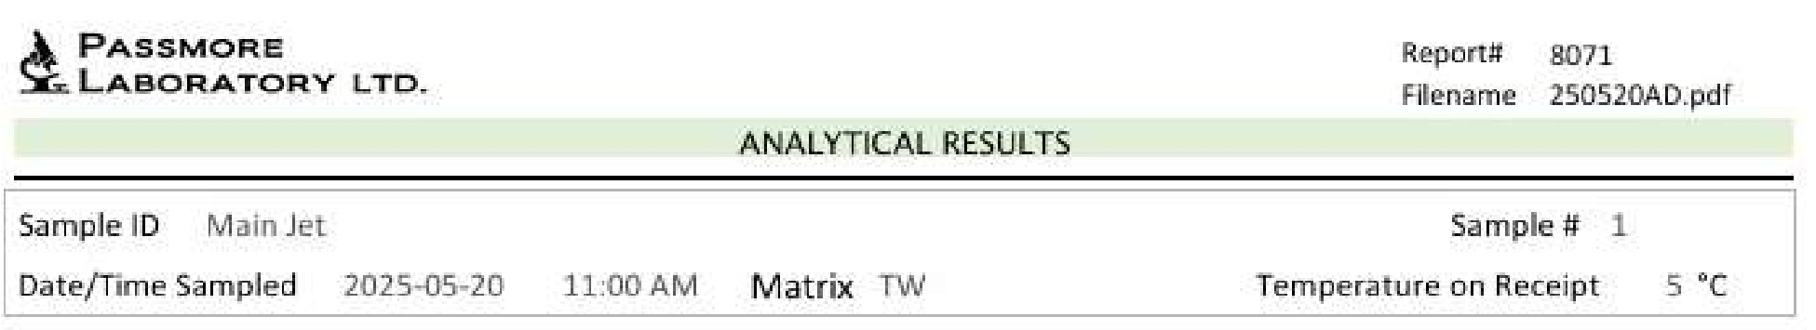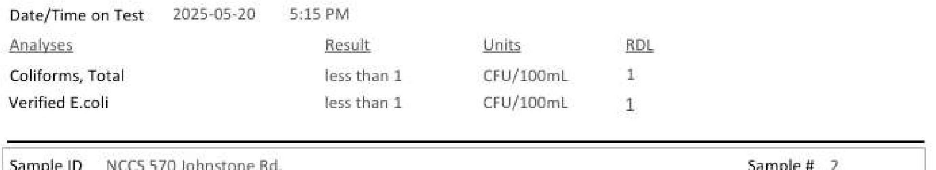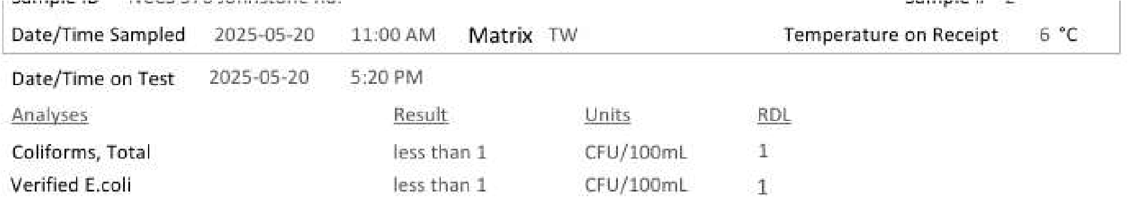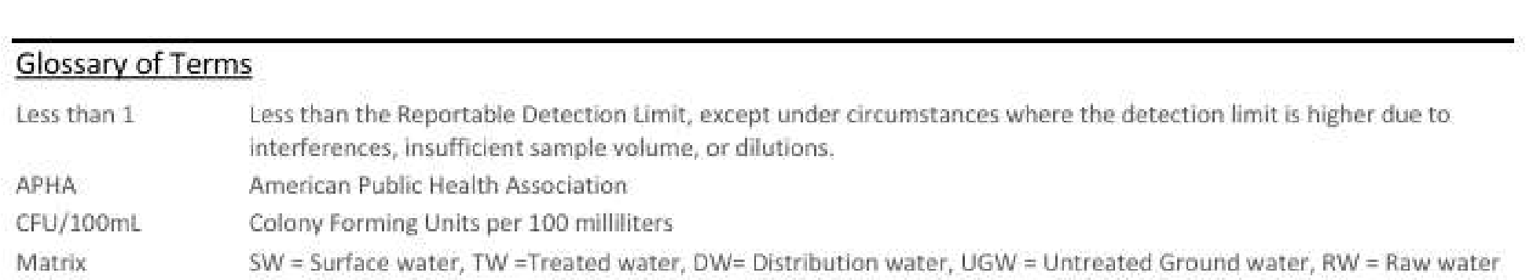

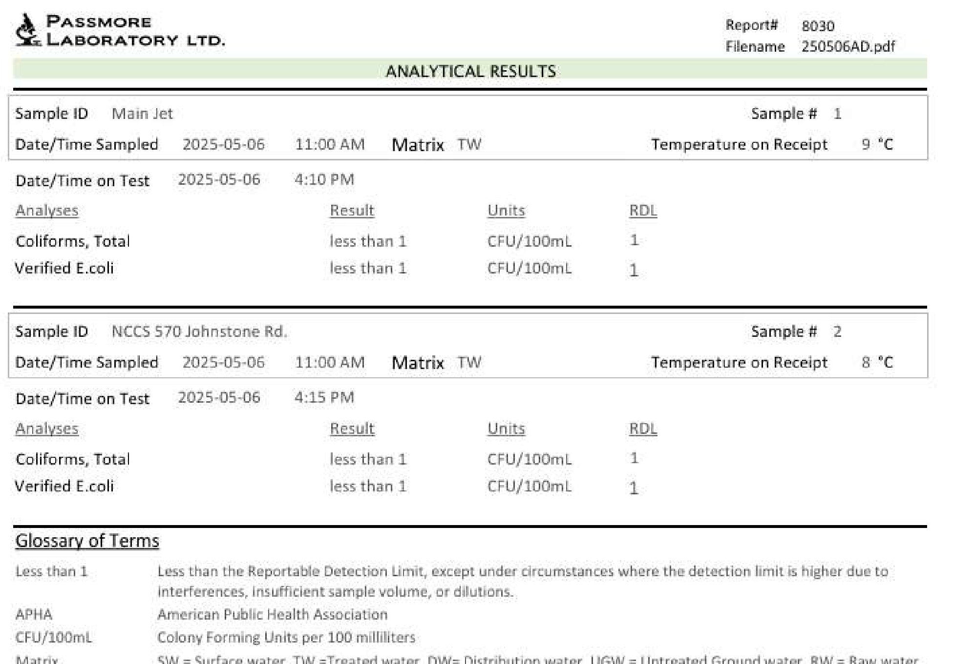

Appendix B
Operator Log Sheet

North Shore Water Utility Nelson Ltd. Monthly Report

To: Jennifer Beverly, Large Water Systems Environmental Health Officer, Interior Health Authority
From: Aqua Diversities Waterworks Inc.
Date: July 8th, 2025
Re: Monthly Report for North Shore Water Utility - June 2025

This document includes the following items as part of the monthly report for the North Shore Water Utility Nelson Ltd. (NSWU):
1.0 Daily Water Consumption
2.0 Microbiological Test Results
3.0 Operator Log Sheets and Water Quality Events
4.0 Major Operational Events
5.0 Records of Customer Feedback and Response
Submission of this report is to enhance communication with the local Environment Health Officer (EHO) and meet requirements for status compliance on the conditions summarized in the Operating Permit.
1.0 Daily Water Consumption
Total water consumption in June was 6,513m³; average daily consumption was 217.1m³/day. The average flow was 9.046m³/hr.

2.0 Microbiological Test Results
A sample from both ends of the distribution system is collected and submitted to an accredited laboratory for bimonthly microbiological testing.
All monthly testing results satisfy the Maximum Allowable Concentration (MAC) standard as set out by the Guidelines for Canadian Drinking Water Quality (GCDWQ).
See Appendix A for Laboratory Results

3.0 Operator Log Sheets and Water Quality Events
NSWU continues to be tested on an every-other-day schedule as specified by the EHO. The log sheets include comments on the source, treatment, and distribution system events. Log sheets also include information on the weather for the corresponding test date, which helps correlate weather events to turbidity levels.
Throughout the month of June, chlorine residuals were maintained above 0.2 mg/L across the distribution system.
See Appendix B for Operator Log Sheets.

4.0 Major Operational Events
Both Issac and Sutherland intakes were cleaned June 5th& 6th. The distribution system was flushed June 23rd-25th, customers were notified via text/email alerts, the website and sandwich boards.
A leaking curb stop was repaired at 541 Johnston Rd. on June 9th. Repairs to the leak at the Sutherland reservoir were complete.

5.0 Records of Customer Feedback and Response
There were no customer inquiries in the month of June.

Report Reviewed by:

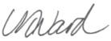
Nicole Ward, BSc.P.Ag. Project Manager

Appendix A
Laboratory Results

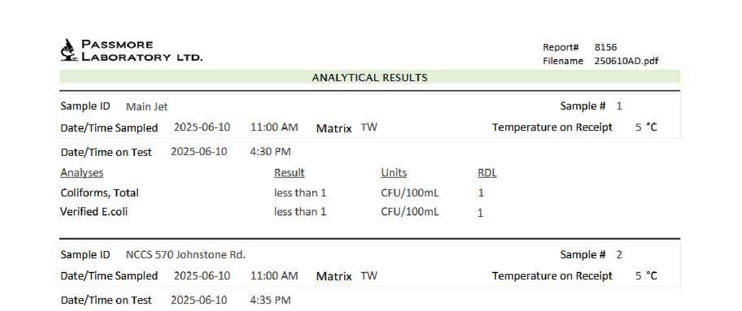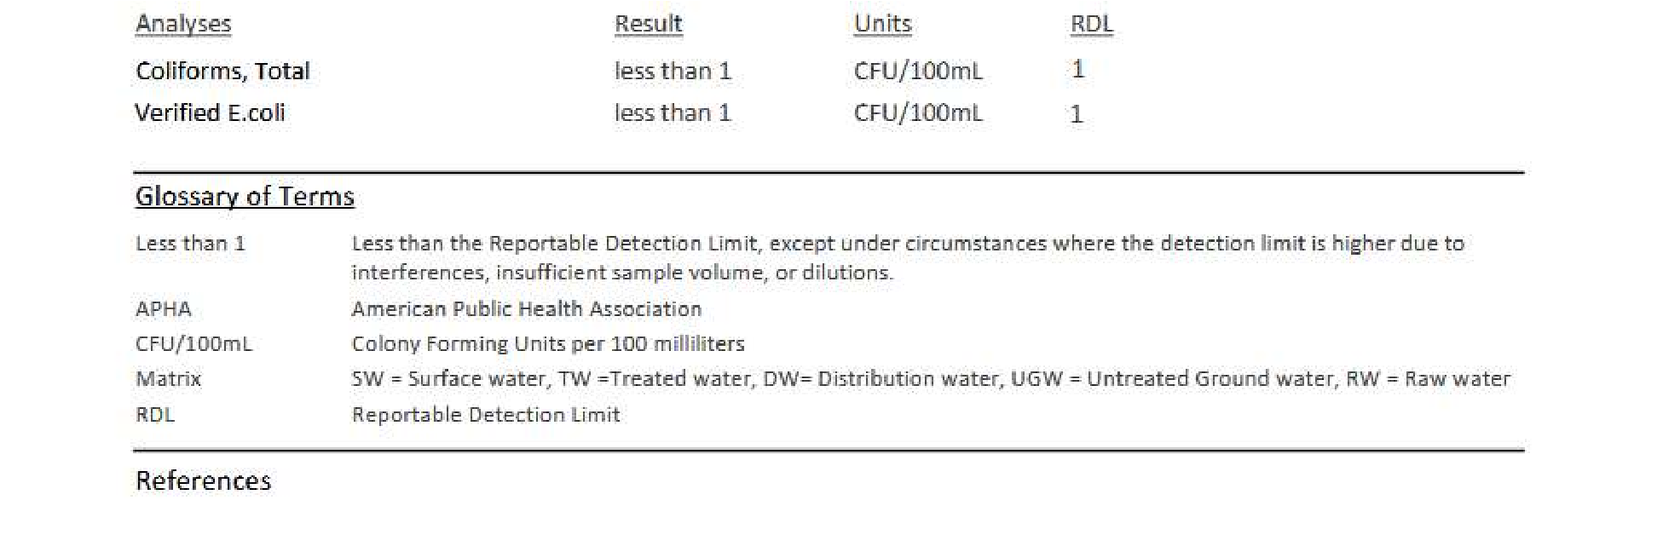

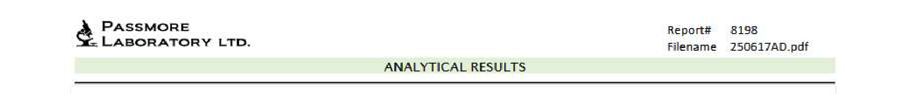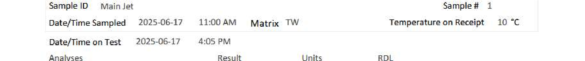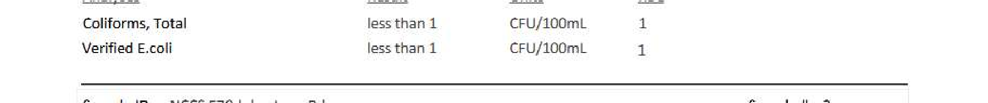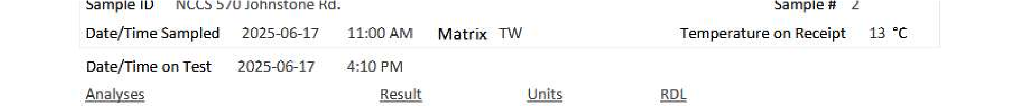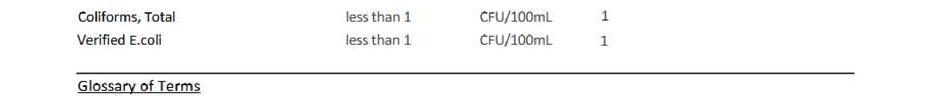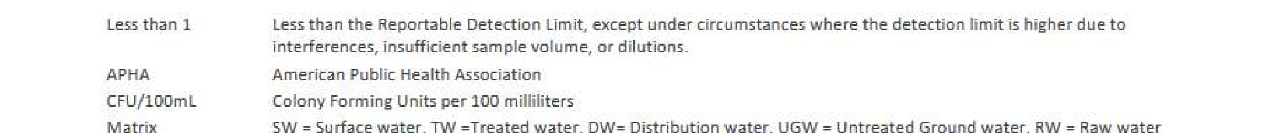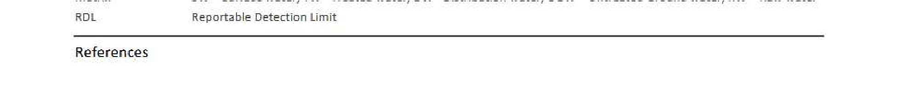

Appendix B
Operator Log Sheet

Appendix C
Field Memos

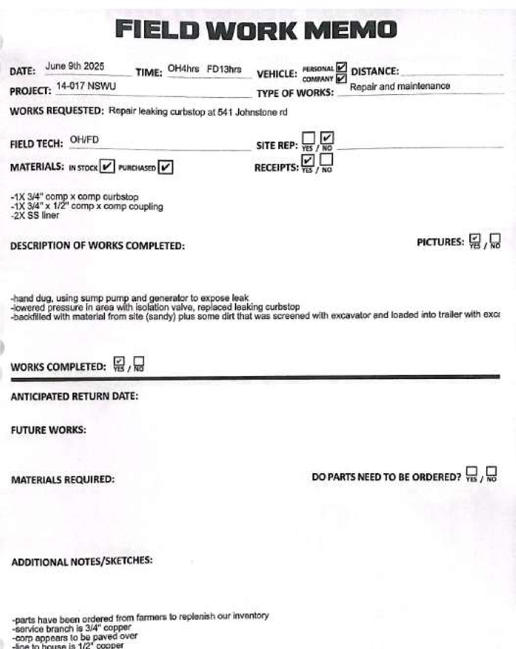
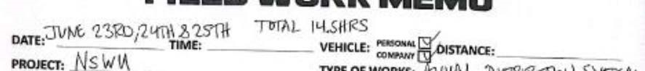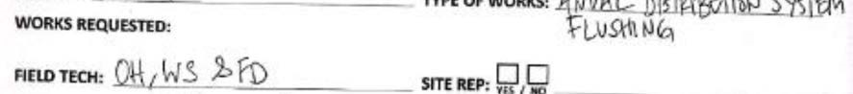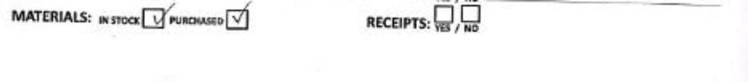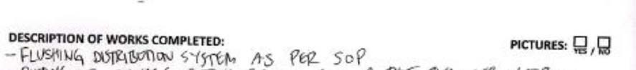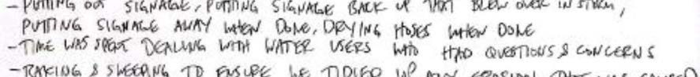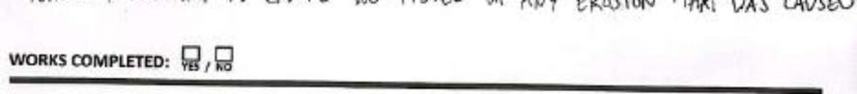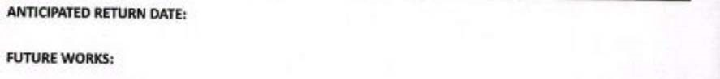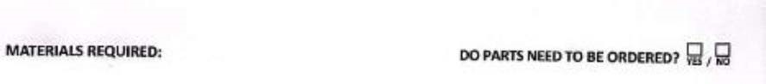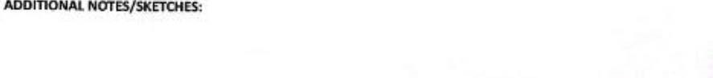

North Shore Water Utility Nelson Ltd. Monthly Report

To: Jennifer Beverly, Large Water Systems Environmental Health Officer, Interior Health Authority
From: AquaDiversities Waterworks Inc.
Date: Aug 20th, 2025
Re: Monthly Report for North Shore Water Utility - July 2025

This document includes the following items as part of the monthly report for the North Shore Water Utility Nelson Ltd. (NSWU):
1.0 Daily Water Consumption
2.0 Microbiological Test Results
3.0 Operator Log Sheets and Water Quality Events
4.0 Major Operational Events

5.0 Records of Customer Feedback and Response
Submission of this report is to enhance communication with the local Environment Health Officer (EHO) and meet requirements for status compliance on the conditions summarized in the Operating Permit.

1.0 Daily Water Consumption
Total water consumption in July was 6,728m³; average daily consumption was 217.0m³/day. The average flow was 9.043m³/hr.

2.0 Microbiological Test Results
A sample from both ends of the distribution system is collected and submitted to an accredited laboratory for bimonthly microbiological testing.
All monthly testing results satisfy the Maximum Allowable Concentration (MAC) standard as set out by the Guidelines for Canadian Drinking Water Quality (GCDWQ).
See Appendix A for Laboratory Results

3.0 Operator Log Sheets and Water Quality Events
NSWU continues to be tested on an every-other-day schedule as specified by the EHO. The log sheets include comments on the source, treatment, and distribution system events. Log sheets also include information on the weather for the corresponding test date, which helps correlate weather events to turbidity levels.
Throughout the month of July, chlorine residuals were maintained above 0.2 mg/L across the distribution system.
See Appendix B for Operator Log Sheets.

4.0 Major Operational Events
5.0 Records of Customer Feedback and Response
There were no customer inquiries in the month of July.

Report Reviewed by:

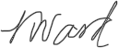
Nicole Ward, BSc.P.Ag. Project Manager

Appendix A
Laboratory Results

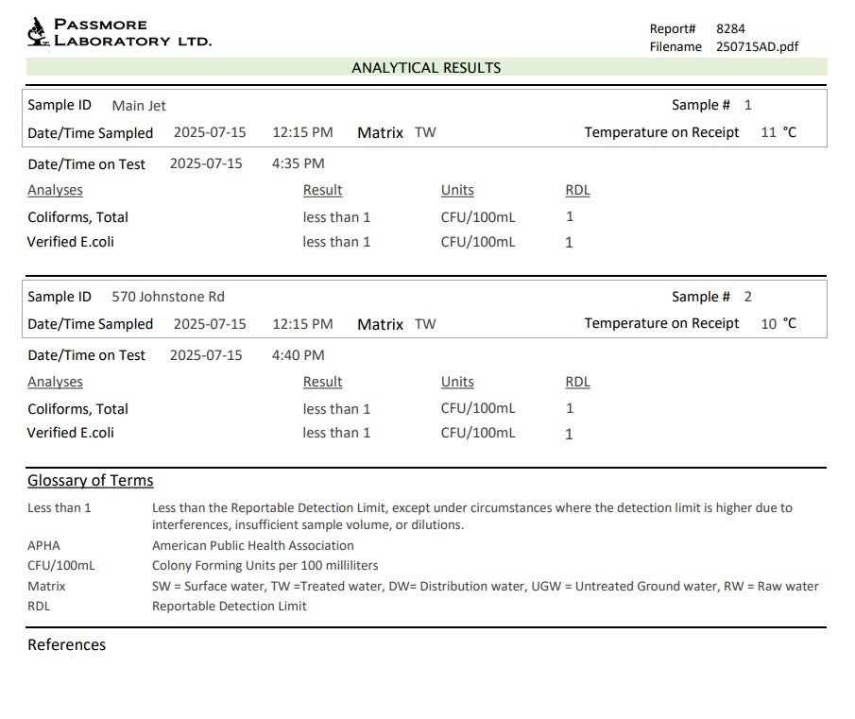

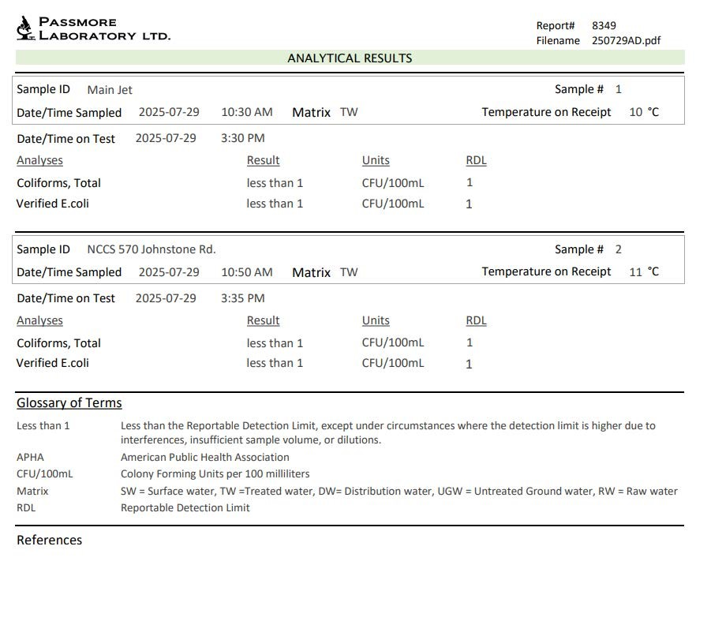

Appendix B
Operator Log Sheet

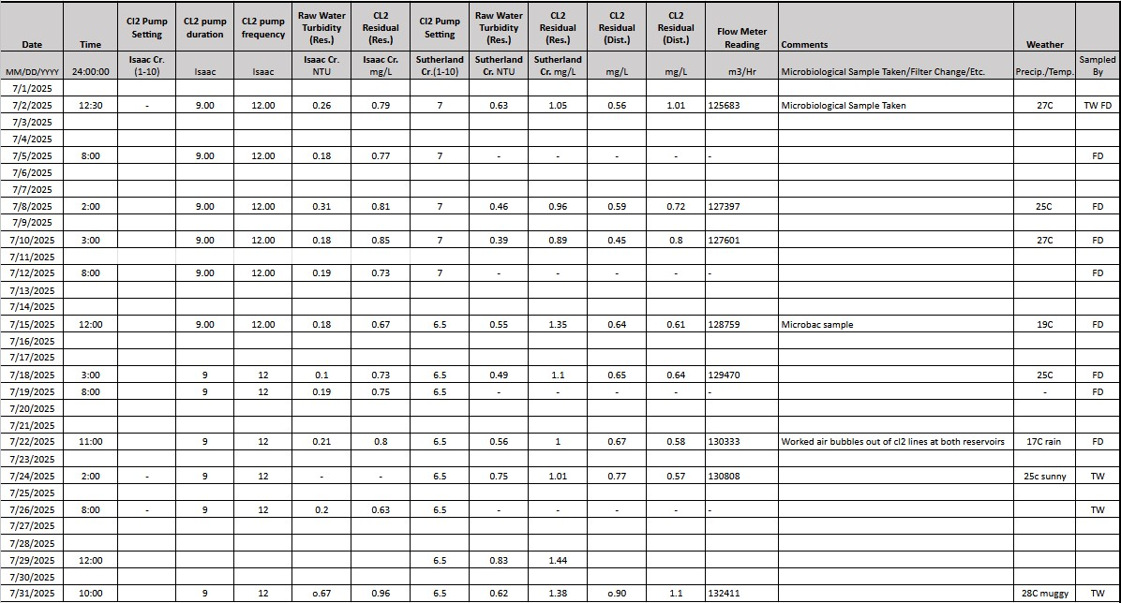

North Shore Water Utility Nelson Ltd. Monthly Report

To: Jennifer Beverly, Large Water Systems Environmental Health Officer, Interior Health Authority
From: AquaDiversities Waterworks Inc.
Date: September 23rd, 2025
Re: Monthly Report for North Shore Water Utility - August 2025

This document includes the following items as part of the monthly report for the North Shore Water Utility Nelson Ltd. (NSWU):
1.0 Daily Water Consumption
2.0 Microbiological Test Results
3.0 Operator Log Sheets and Water Quality Events
4.0 Major Operational Events
5.0 Records of Customer Feedback and Response

Submission of this report is to enhance communication with the local Environment Health Officer (EHO) and meet requirements for status compliance on the conditions summarized in the Operating Permit.

1.0 Daily Water Consumption
Total water consumption in August was 6,396m³; average daily consumption was 206.3m³/day. The average flow was 8.597m³/hr.

2.0 Microbiological Test Results
A sample from both ends of the distribution system is collected and submitted to an accredited laboratory for bimonthly microbiological testing.
All monthly testing results satisfy the Maximum Allowable Concentration (MAC) standard as set out by the Guidelines for Canadian Drinking Water Quality (GCDWQ).
See Appendix A for Laboratory Results

3.0 Operator Log Sheets and Water Quality Events
NSWU continues to be tested on an every-other-day schedule as specified by the EHO. The log sheets include comments on the source, treatment, and distribution system events. Log sheets also include information on the weather for the corresponding test date, which helps correlate weather events to turbidity levels.
Throughout the month of August, chlorine residuals were maintained above 0.2 mg/L across the distribution system.
See Appendix B for Operator Log Sheets.

4.0 Major Operational Events
Both the Sutherland and the Isaac intake were cleaned of sediment buildup on the 8th of August. Drainage bars accessing the Isaac intake were cleaned on the 14th of August. The Curb stops at 673 and 661 Parkview Road were located and brought up to grade.

5.0 Records of Customer Feedback and Response
There were no customer inquiries in the month of August.

Report Reviewed by:

Nicole Ward, BSc.P.Ag. Project Manager

Appendix A
Laboratory Results

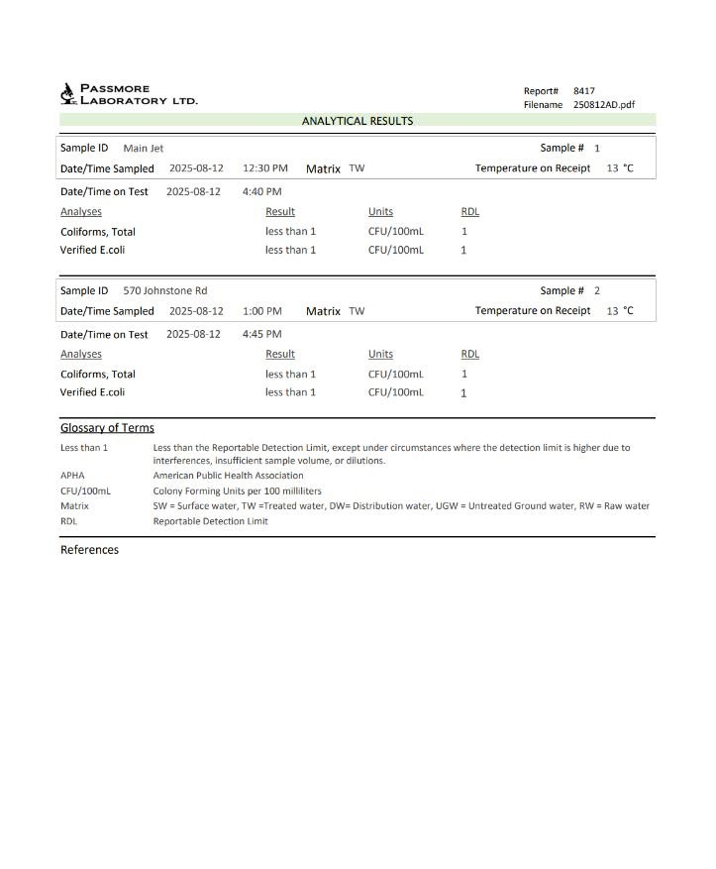
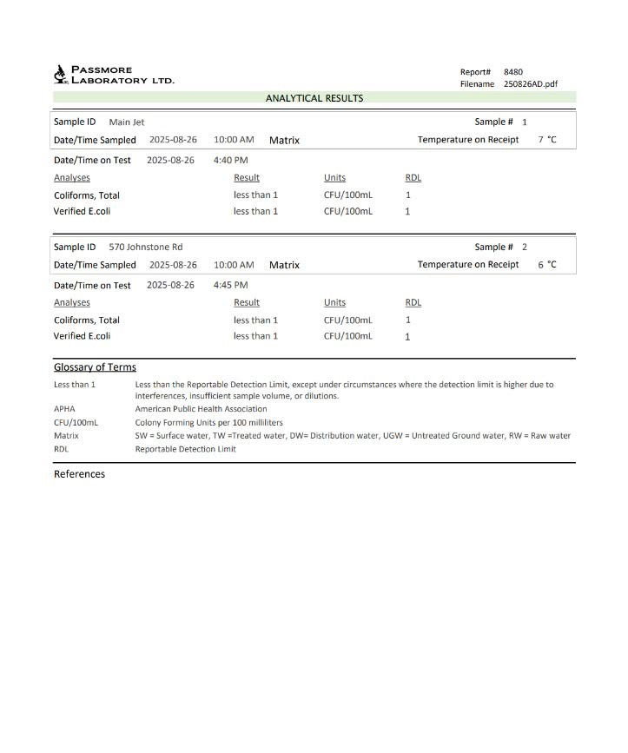

Appendix B
Operator Log Sheet

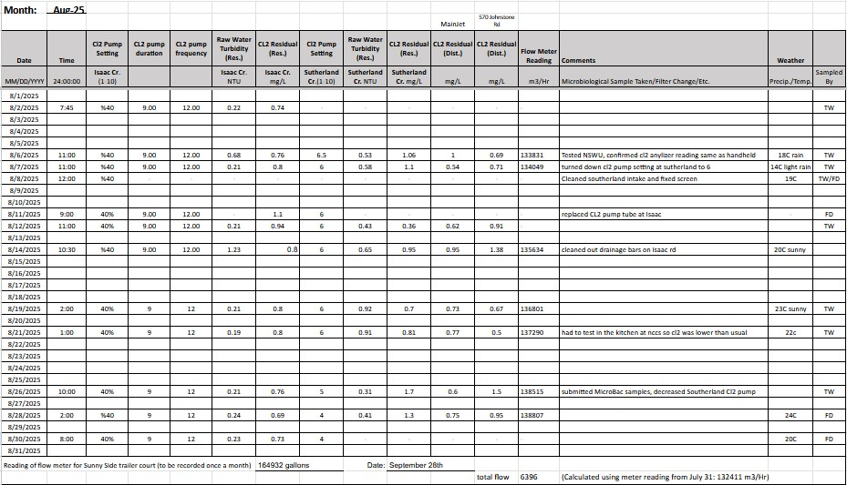

Appendix C
Field Memos

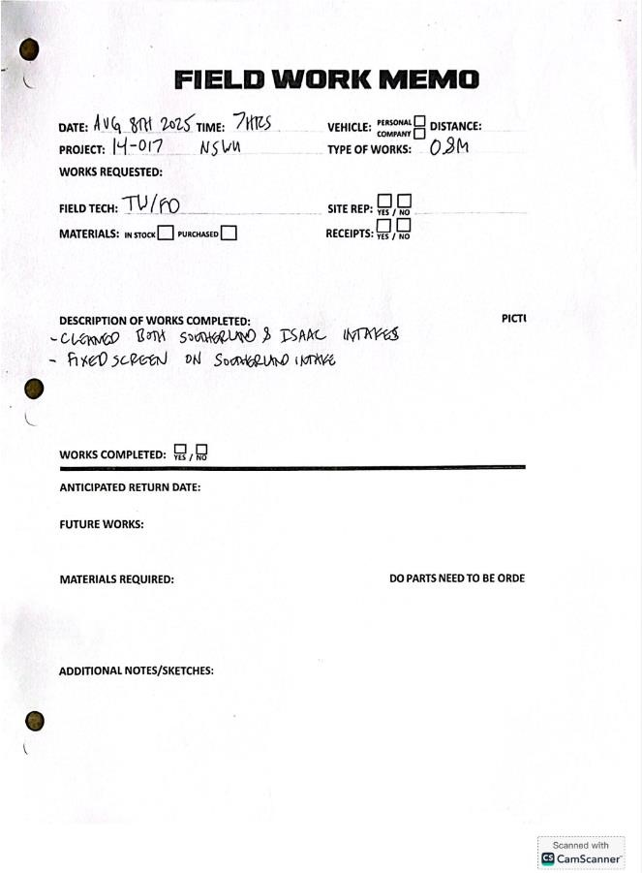
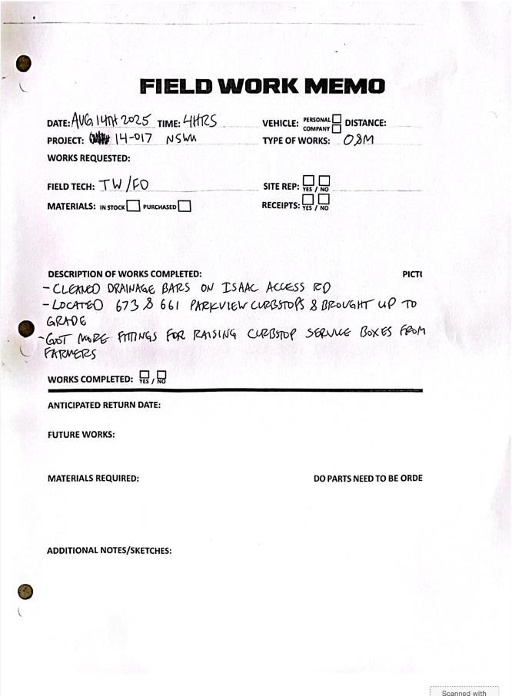

North Shore Water Utility Nelson Ltd. Monthly Report

To: Jennifer Beverly, Large Water Systems Environmental Health Officer, Interior Health Authority
From: AquaDiversities Waterworks Inc.
Date: October 21st, 2025
Re: Monthly Report for North Shore Water Utility - September 2025

This document includes the following items as part of the monthly report for the North Shore Water Utility Nelson Ltd. (NSWU):
1.0 Daily Water Consumption
2.0 Microbiological Test Results
3.0 Operator Log Sheets and Water Quality Events
4.0 Major Operational Events
5.0 Records of Customer Feedback and Response

Submission of this report is to enhance communication with the local Environment Health Officer (EHO) and meet requirements for status compliance on the conditions summarized in the Operating Permit.

1.0 Daily Water Consumption
Total water consumption in September was 5,011m³; average daily consumption was 167.0m³/day. The average flow was 6.960m³/hr.

2.0 Microbiological Test Results
A sample from both ends of the distribution system is collected and submitted to an accredited laboratory for bimonthly microbiological testing.
All monthly testing results satisfy the Maximum Allowable Concentration (MAC) standard as set out by the Guidelines for Canadian Drinking Water Quality (GCDWQ).
See Appendix A for Laboratory Results

3.0 Operator Log Sheets and Water Quality Events
NSWU continues to be tested on an every-other-day schedule as specified by the EHO. The log sheets include comments on the source, treatment, and distribution system events. Log sheets also include information on the weather for the corresponding test date, which helps correlate weather events to turbidity levels.
Throughout the month of September, chlorine residuals were maintained above 0.2 mg/L across the distribution system.
See Appendix B for Operator Log Sheets.

4.0 Major Operational Events
Two “brookes” boxes were installed this month. One box was installed at the junction of Johnston and Whitmore to facilitate a flushing point, and one was installed at the Sutherland reservoir. Additional time by staff in September was spent searching for curb stops as time permitted.

5.0 Records of Customer Feedback and Response
A resident from 683 Whitmore Road inquired about a water leak on September 3rd. The property curbstop valve was closed, the leak was determined to be on the resident’s property, and he was advised to contact a plumber. The curb-stop valve was left closed for repairs. No other customer comments or complaints were received in the month of September.

Report Reviewed by:

Nicole Ward, BSc.P.Ag. Project Manager

Appendix A
Laboratory Results

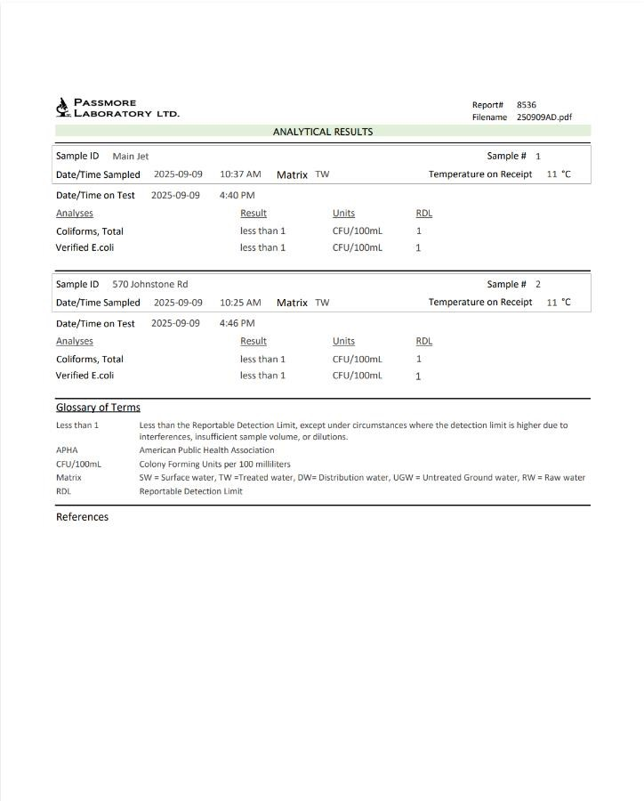
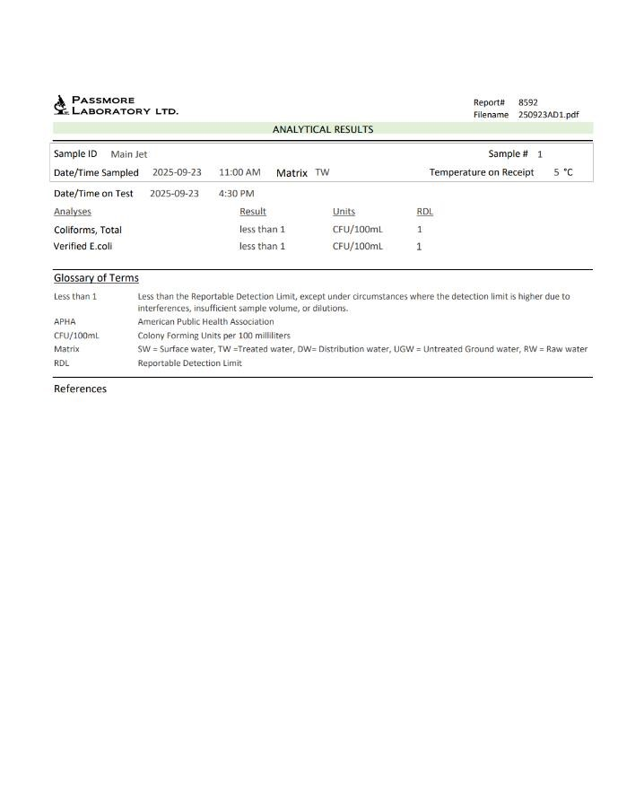

Appendix B
Operator Log Sheet

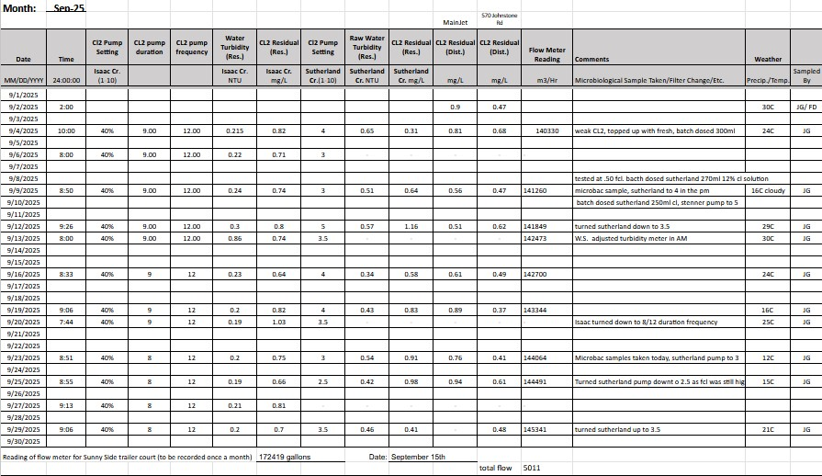

Appendix C
Field Memos

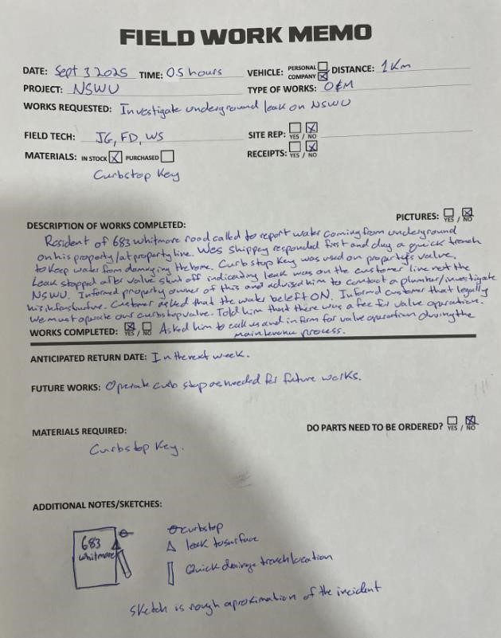
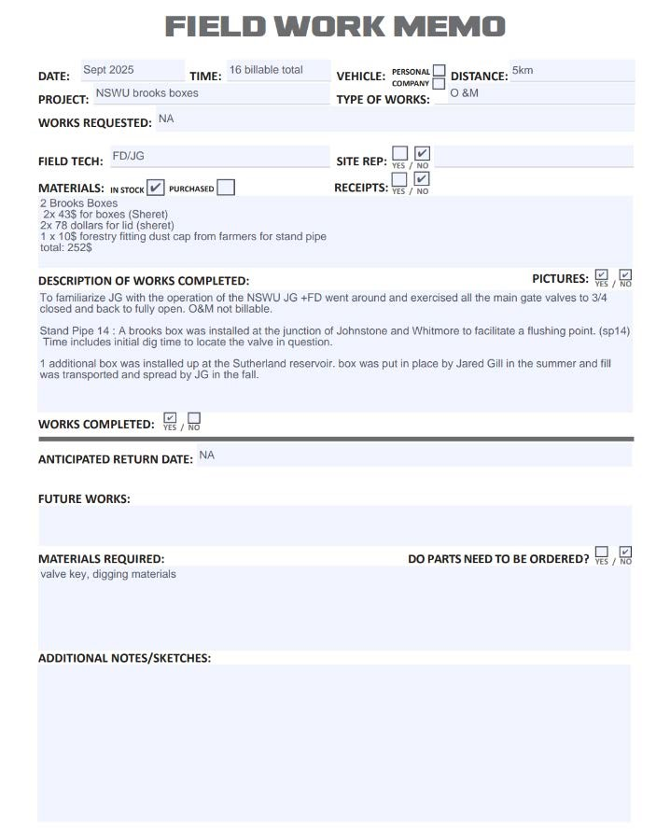
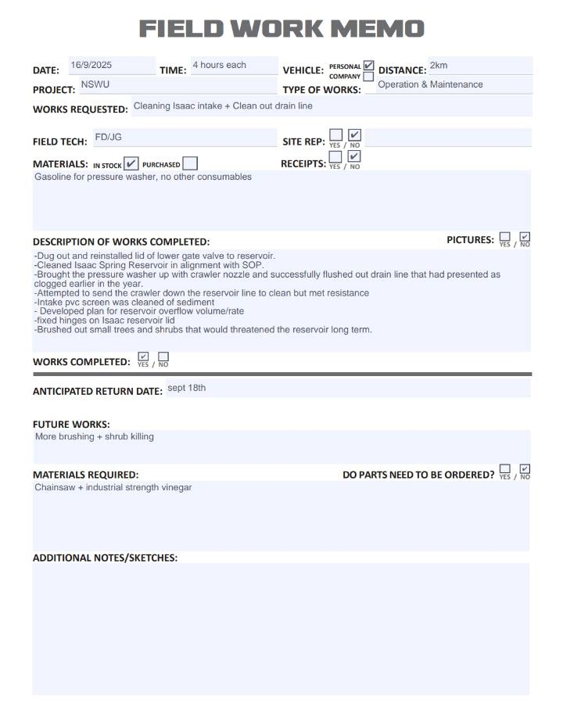
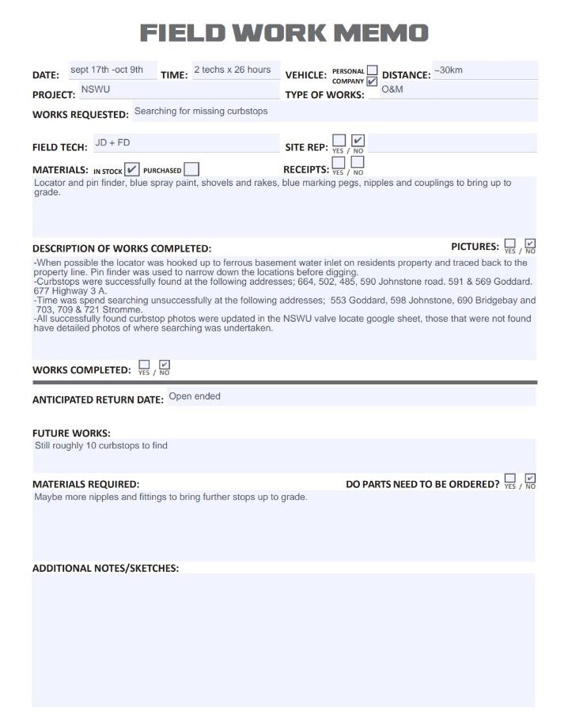

North Shore Water Utility Nelson Ltd. Monthly Report

To: Jennifer Beverly, Large Water Systems Environmental Health Officer, Interior Health Authority
From: AquaDiversities Waterworks Inc.
Date: December 19th, 2026
Re: Monthly Report for North Shore Water Utility - October 2025

This document includes the following items as part of the monthly report for the North Shore Water Utility Nelson Ltd. (NSWU):
1.0 Daily Water Consumption
2.0 Microbiological Test Results
3.0 Operator Log Sheets and Water Quality Events
4.0 Major Operational Events

5.0 Records of Customer Feedback and Response
Submission of this report is to enhance communication with the local Environment Health Officer (EHO) and meet requirements for status compliance on the conditions summarized in the Operating Permit.

1.0 Daily Water Consumption
Total water consumption in October was 5,166m³; average daily consumption was 166.6m³/day. The average flow was 6.94m³/hr.

2.0 Microbiological Test Results
A sample from both ends of the distribution system is collected and submitted to an accredited laboratory for bimonthly microbiological testing.
All monthly testing results satisfy the Maximum Allowable Concentration (MAC) standard as set out by the Guidelines for Canadian Drinking Water Quality (GCDWQ).
See Appendix A for Laboratory Results

3.0 Operator Log Sheets and Water Quality Events
NSWU continues to be tested on an every-other-day schedule as specified by the EHO. The log sheets include comments on the source, treatment, and distribution system events. Log sheets also include information on the weather for the corresponding test date, which helps correlate weather events to turbidity levels.
Throughout the month of October, chlorine residuals were maintained above 0.2 mg/L across the distribution system.
See Appendix B for Operator Log Sheets.

4.0 Major Operational Events
Lead testing was completed at the NCSS Christian school per the request of the principal in preparation for an annual inspection.

5.0 Records of Customer Feedback and Response
There were no customer inquiries in the month of October.

Report Reviewed by:

Nicole Ward, BSc.P.Ag. Project Manager

Appendix A
Laboratory Results

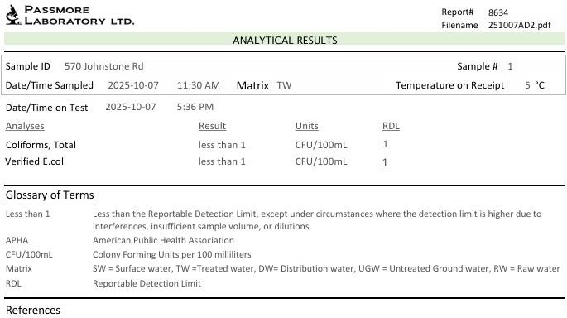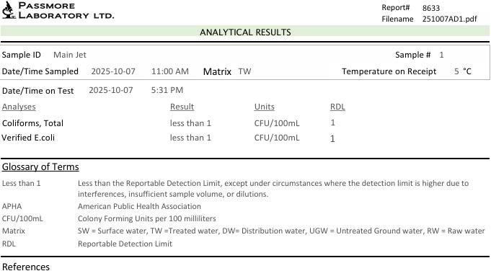

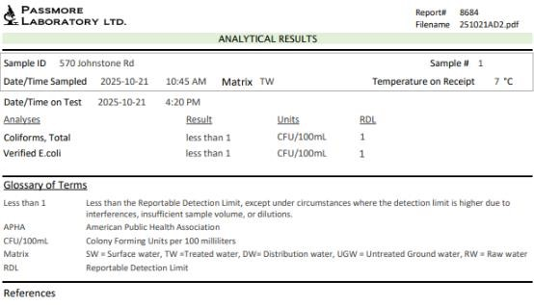

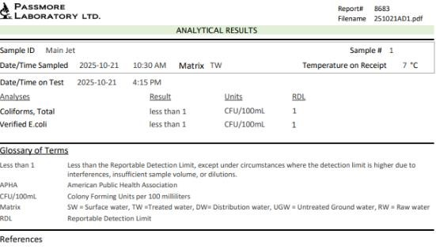

Appendix B
Operator Log Sheet

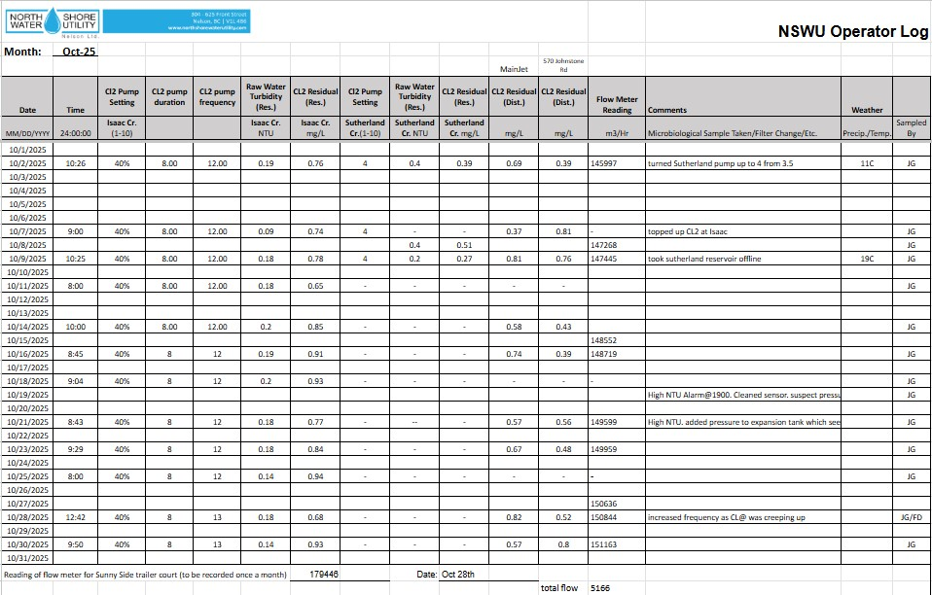

North Shore Water Utility Nelson Ltd. Monthly Report

To: Jennifer Beverly, Large Water Systems Environmental Health Officer, Interior Health Authority
From: AquaDiversities Waterworks Inc.
Date: December 13th, 2026
Re: Monthly Report for North Shore Water Utility - November 2025

This document includes the following items as part of the monthly report for the North Shore Water Utility Nelson Ltd. (NSWU):
1.0 Daily Water Consumption
2.0 Microbiological Test Results
3.0 Operator Log Sheets and Water Quality Events
4.0 Major Operational Events

5.0 Records of Customer Feedback and Response
Submission of this report is to enhance communication with the local Environment Health Officer (EHO) and meet requirements for status compliance on the conditions summarized in the Operating Permit.

1.0 Daily Water Consumption
Total water consumption in September was 4,778m³; average daily consumption was 159.3m³/day. The average flow was 6.64m³/hr.

2.0 Microbiological Test Results
A sample from both ends of the distribution system is collected and submitted to an accredited laboratory for bimonthly microbiological testing.
All monthly testing results satisfy the Maximum Allowable Concentration (MAC) standard as set out by the Guidelines for Canadian Drinking Water Quality (GCDWQ).
See Appendix A for Laboratory Results

3.0 Operator Log Sheets and Water Quality Events
NSWU continues to be tested on an every-other-day schedule as specified by the EHO. The log sheets include comments on the source, treatment, and distribution system events. Log sheets also include information on the weather for the corresponding test date, which helps correlate weather events to turbidity levels.
Throughout the month of November, chlorine residuals were maintained above 0.2 mg/L across the distribution system.
See Appendix B for Operator Log Sheets.

4.0 Major Operational Events
There were no major operational events in November.
5.0 Records of Customer Feedback and Response
There were no customer inquiries in the month of November.

Report Reviewed by:

Nicole Ward, BSc.P.Ag. Project Manager

Appendix A
Laboratory Results

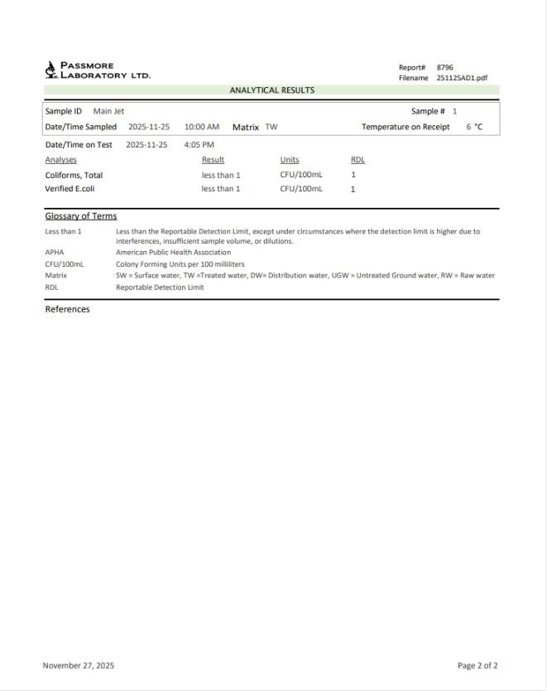
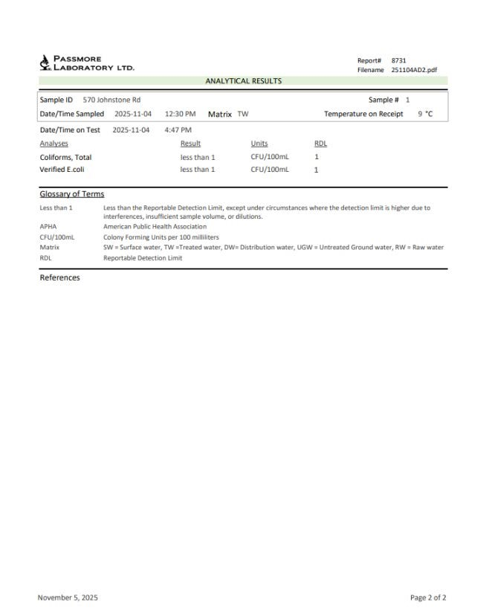
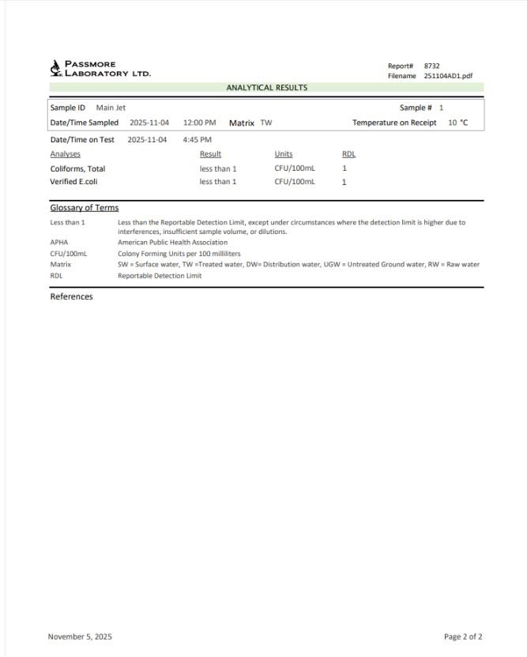
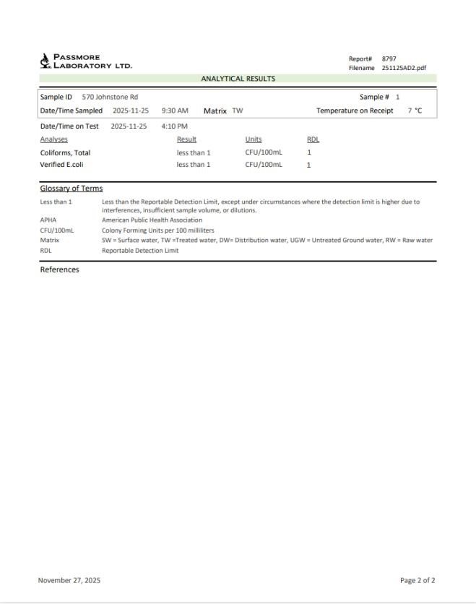

Appendix B
Operator Log Sheet

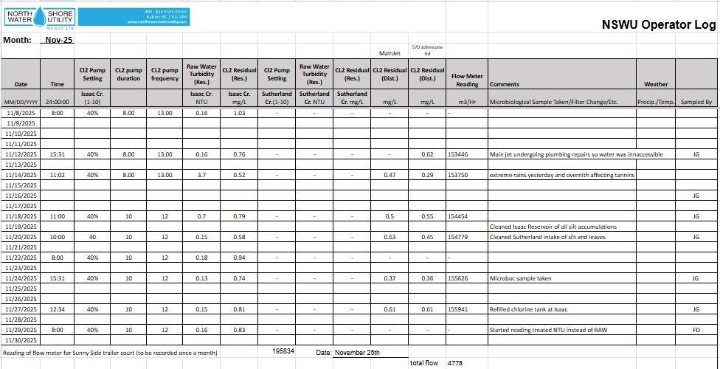

North Shore Water Utility Nelson Ltd. Monthly Report

To: Jennifer Beverly, Large Water Systems Environmental Health Officer, Interior Health Authority From: AquaDiversities Waterworks Inc.
Date: January 22nd, 2026
Re: Monthly Report for North Shore Water Utility – December 2025

This document includes the following items as part of the monthly report for the North Shore Water Utility Nelson Ltd. (NSWU):
1.0 Daily Water Consumption
2.0 Microbiological Test Results
3.0 Operator Log Sheets and Water Quality Events
4.0 Major Operational Events
5.0 Records of Customer Feedback and Response

Submission of this report is to enhance communication with the local Environment Health Officer (EHO) and meet requirements for status compliance on the conditions summarized in the Operating Permit.

1.0 Daily Water Consumption
Total water consumption in September was 4,798 m³; average daily consumption was 154.8m³/day. The average flow was 6.449m³/hr.

2.0 Microbiological Test Results
A sample from both ends of the distribution system is collected and submitted to an accredited laboratory for bimonthly microbiological testing.
All monthly testing results satisfy the Maximum Allowable Concentration (MAC) standard as set out by the Guidelines for Canadian Drinking Water Quality (GCDWQ).
See Appendix A for Laboratory Results

3.0 Operator Log Sheets and Water Quality Events
NSWU continues to be tested on an every-other-day schedule as specified by the EHO. The log sheets include comments on the source, treatment, and distribution system events. Log sheets also include information on the weather for the corresponding test date, which helps correlate weather events to turbidity levels.
Throughout the month of December, chlorine residuals were maintained above 0.2 mg/L across the distribution system.
A water quality advisory (WQA) was posted on December 11th 2025 due to turbidity (NTU) levels being above 1.0 for more than 48 hours. The WQA stayed in effect for the rest month. Turbidity levels fluctuated around the 1.0 level due to heavy rainfall and unseasonal warm temperatures. Customers were notified by email, text alerts, the website and sandwich boards were put out in the community.
To try and mitigate this the Sutherland intake was cleaned several times and the chlorination rate was increased to ensure an appropriate residual at end of distribution.
AquaDiversities rescinded the WQA in early January 2026. This came after a several days of NTU readings below 1.0 and a passing micro bacterial sample. This was in alignment with the recommendations of the Environmental Health Officer.
See Appendix B for Operator Log Sheets.

4.0 Major Operational Events
The posting of the water quality advisory marks the only major operational event of the month.

5.0 Records of Customer Feedback and Response
There were no customer inquiries or feedback forms reported during the month of December.

Report Reviewed by:

Nicole Ward, BSc.P.Ag. Project Manager

Appendix A
Laboratory Results

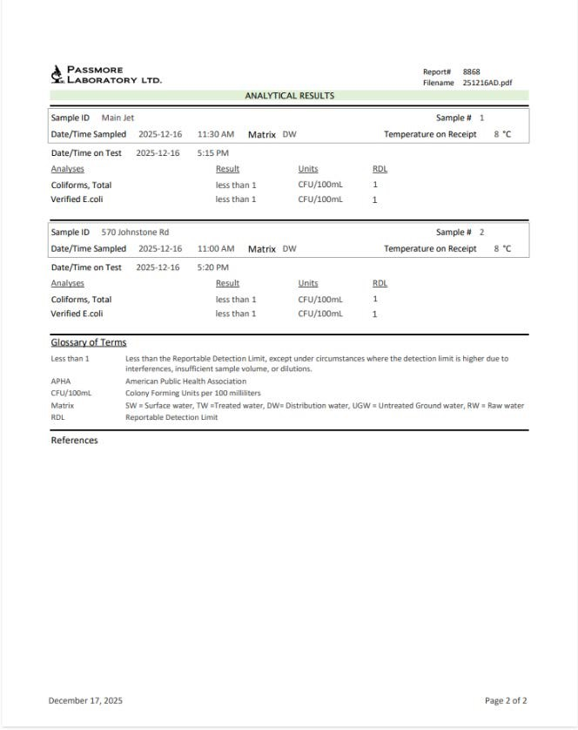
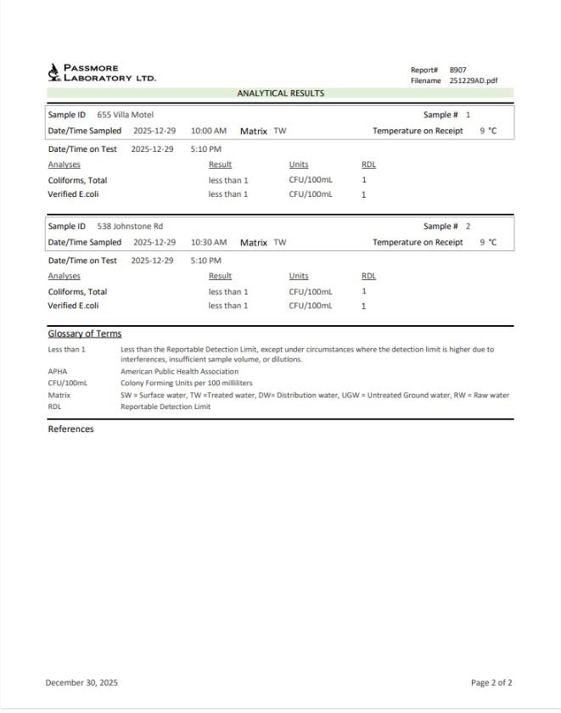

Appendix B
Operator Log Sheet

